**Joint Accreditation (JA) Application Checklist**

**(Companion Guide)**

**Revised March 1, 2024**

Before beginning the online application, it is important to know:

* What is the practice-based problem you trying to address?
* How do you know this is a practice gap (formal/informal needs assessment)?
* How will you measure your success?

**BASIC INFORMATION (TAB 1)**

Sponsoring Department Listed

Activity Name Listed

*Accreditation Type/Target Audience Identified

**Select all that apply:**

**ACCME** (Accreditation Council for Continuing Medical Education) – *Physicians*

**ANCC** (American Nursing Credentialing Center) – *Nurses*

**AAPA** ( American Academy of Physician Associates) – *Physician Assistants*

**ASWB** (Association of Social Work Boards) – *Social Workers*

**Non-Accredited** (activity will not offer credit)

**ADA CERP** (American Dental Association’s Continuing Education Recognition Program) - *Dentists, Dental Assistants*

**ACPE** (Accreditation Council for Pharmacy Education) – *Pharmacists and/or Pharmacy Technicians*

**APA** (American Psychological Association) – *Psychologists*

**Joint Accredited (JA)** (only check if more than 1 accreditation type checked above)

*If more than 2 types, **Joint Accreditation** box *must be* checked. This is important for JA activities; the additional information on gaps and needs will not display if unchecked.

*Was this activity planned by the healthcare team, for the healthcare team? Yes or No checked

*Should be Yes if joint accredited box was checked

Are you charging a registration fee? Yes No

*If you are offering CME credit and *not* charging a fee and non-NCH/OSU referring physicians will be attending, **Stark law** applies (non-monetary compensation), and physicians must be reported in the hc1 database. The current fair market value (FMV) rate is $25 per credit claimed. Physicians cannot exceed $507 in non-monetary competition in 2024. The activity coordinator is responsible for reporting.

**Activity Scope** (check one) - (Internal only, local, regional, national, international)

Does this activity fulfill any special Ohio CE requirements? (Check Yes or No)

*If you select Yes, these additional response options will load:*

Number of Hours: (You can't leave this empty)

State of Ohio Required Course Designation:

Ethics

Supervision (excludes MFTs)

Law

Pharmacology

ADA

Cultural Competency

Medication Safety

Other (please specify below):

**NCH QSS Priorities** Identified (you can ignore; **this section is no longer required**)

**Activity Format (select one option from dropdown):**

(Directly Provided or Jointly Provided RSS, Course, Enduring Material)

**Directly Provided** – NCH accredits activity. \***Jointly Provided** - Providership of a CME activity by one or more ***accredited*** and one or more ***non-accredited*** organizations. Nearly all NCH activities are directly provided. Note that this is not the same as *Joint Accreditation*.

**Regularly Scheduled Series (RSS)** - A course that is planned as a series with multiple, ongoing sessions, e.g., offered weekly, monthly, or quarterly; and is primarily planned by and presented to the accredited organization’s professional staff. Examples: grand rounds, tumor boards, and morbidity and mortality conferences. A **Course** is an individual event where the learner participates in person. If the same course is held multiple times for different audiences, then each instance is reported as a separate activity. An **Enduring Material** is a printed, recorded, or computer-presented activity that endures over a specified time and does not have a specific time or location designated for participation; rather, the participant determines whether and when to complete the activity. Must review each enduring material at least once every three years or more frequently if indicated by new scientific developments.

**Delivery Method**: (Check all that apply): In-Person and/or Livestreamed for Live events; Online or Print/Other for Enduring Materials

**Activity Type/Format** (additional questions will appear based on the type of professions checked)

**Activity Synopsis** – *short summary* that will display in the CloudCME course listing (optional)

**Activity Description** – *detailed summary* that will display in the CloudCME course listing and marketing materials (optional)

Does the content of this activity contain **clinical or non-clinical** (i.e. leadership, communication, ethics, professional responsibilities, etc.)?

Clinical, Non-Clinical, or Combination of Both – one box must be checked.

**Type of Credit** (note: a representative from each profession type requesting credit must be included on the planning committee *except* physician assistants.)

*Should match up to the target audience selected in section 1 for the JA credit types.*

The **JA** ***credit types*** are: AMA PRA Category 1 Credit (physicians), ANCC (nurses), APA (psychologists), ASWB ACE (social workers), ADA CERP (dentists, dental assistants, AAPA, ACPE, Athletic Trainer. Additional non-JA credit types are also listed. Please note, this application will only be reviewed for JA credit types ***plus*** Pharmacology, Counselors and MFTs.

**\*Note: Non-physician attendance should always be checked if AMA PRA credit is checked.**

Several other credits are tracked in CloudCME but are not part of Joint Accreditation.

**Number of credits** – more than 2 hours must have an agenda attached. Round credits to the nearest quarter hour and do not include lunch, breaks, welcome, closing comments in the calculation.

Anticipated **Number of Participants** (optional field)

**MOC** (Maintenance of Certification) box checked (yes or no) If yes, additional section will appear listing types and points. See the LMS Administrator or email [IPCE@nationwidechildrens.org](mailto:IPCE@nationwidechildrens.org) if you have an application requesting MOC for further guidance.

**Location** listed (no city/state if online only)

**Start and End Date and Time** (Note for RSS the start and end date should be the same; individual sessions (children) will be created for the event (parent) once approved.

**Target Audience**: Specialties section (optional)

**PLANNERS AND FACULTY (TAB 2)**

***Before beginning, you will need the full name, credential and email address for each planner and faculty member***

***Planners*** identified and all fields complete (all JA credit types requested must be represented on planning committee, except physician assistants).

***Faculty*** identified and all fields complete

**Note:** A system email will be automatically generated to all planners and faculty listed requesting a disclosure form be completed/confirmed/updated. This form must be obtained for all before you will be able to submit the application for review. (If anything other than “Nothing to Disclose” is noted, any conflicts of interest noted must be mitigated by IPCE Program Lead or designee)

**GAP AND NEEDS (TAB 3)**

**Professional Practice gap** described and meets the definition. This is not a description or summary of the activity but rather, the a description of the difference between current and best practice.

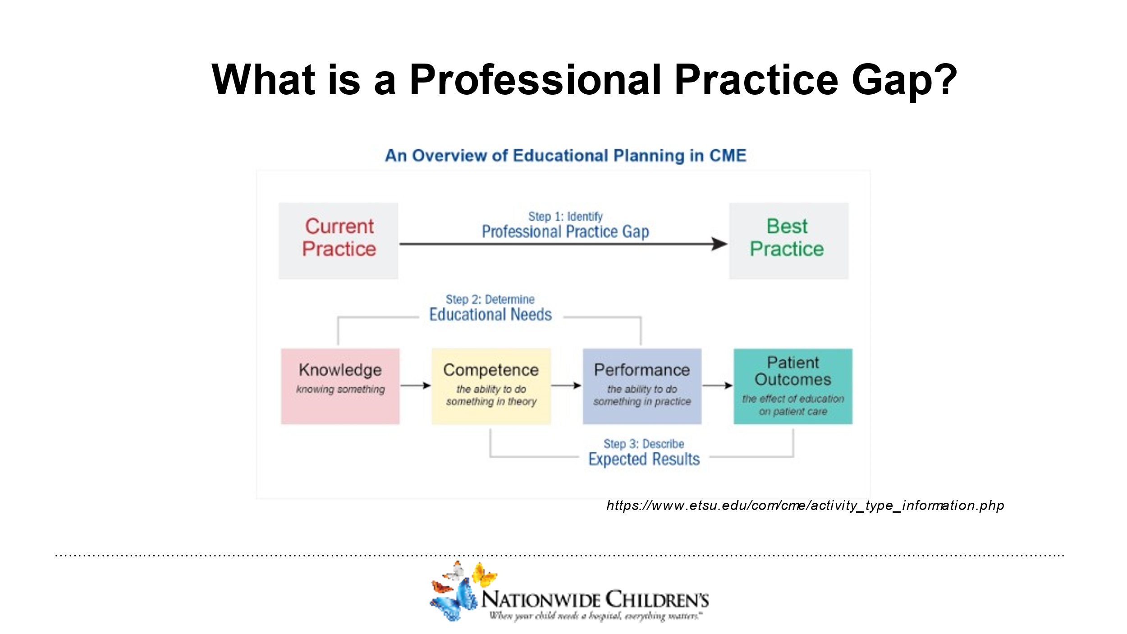

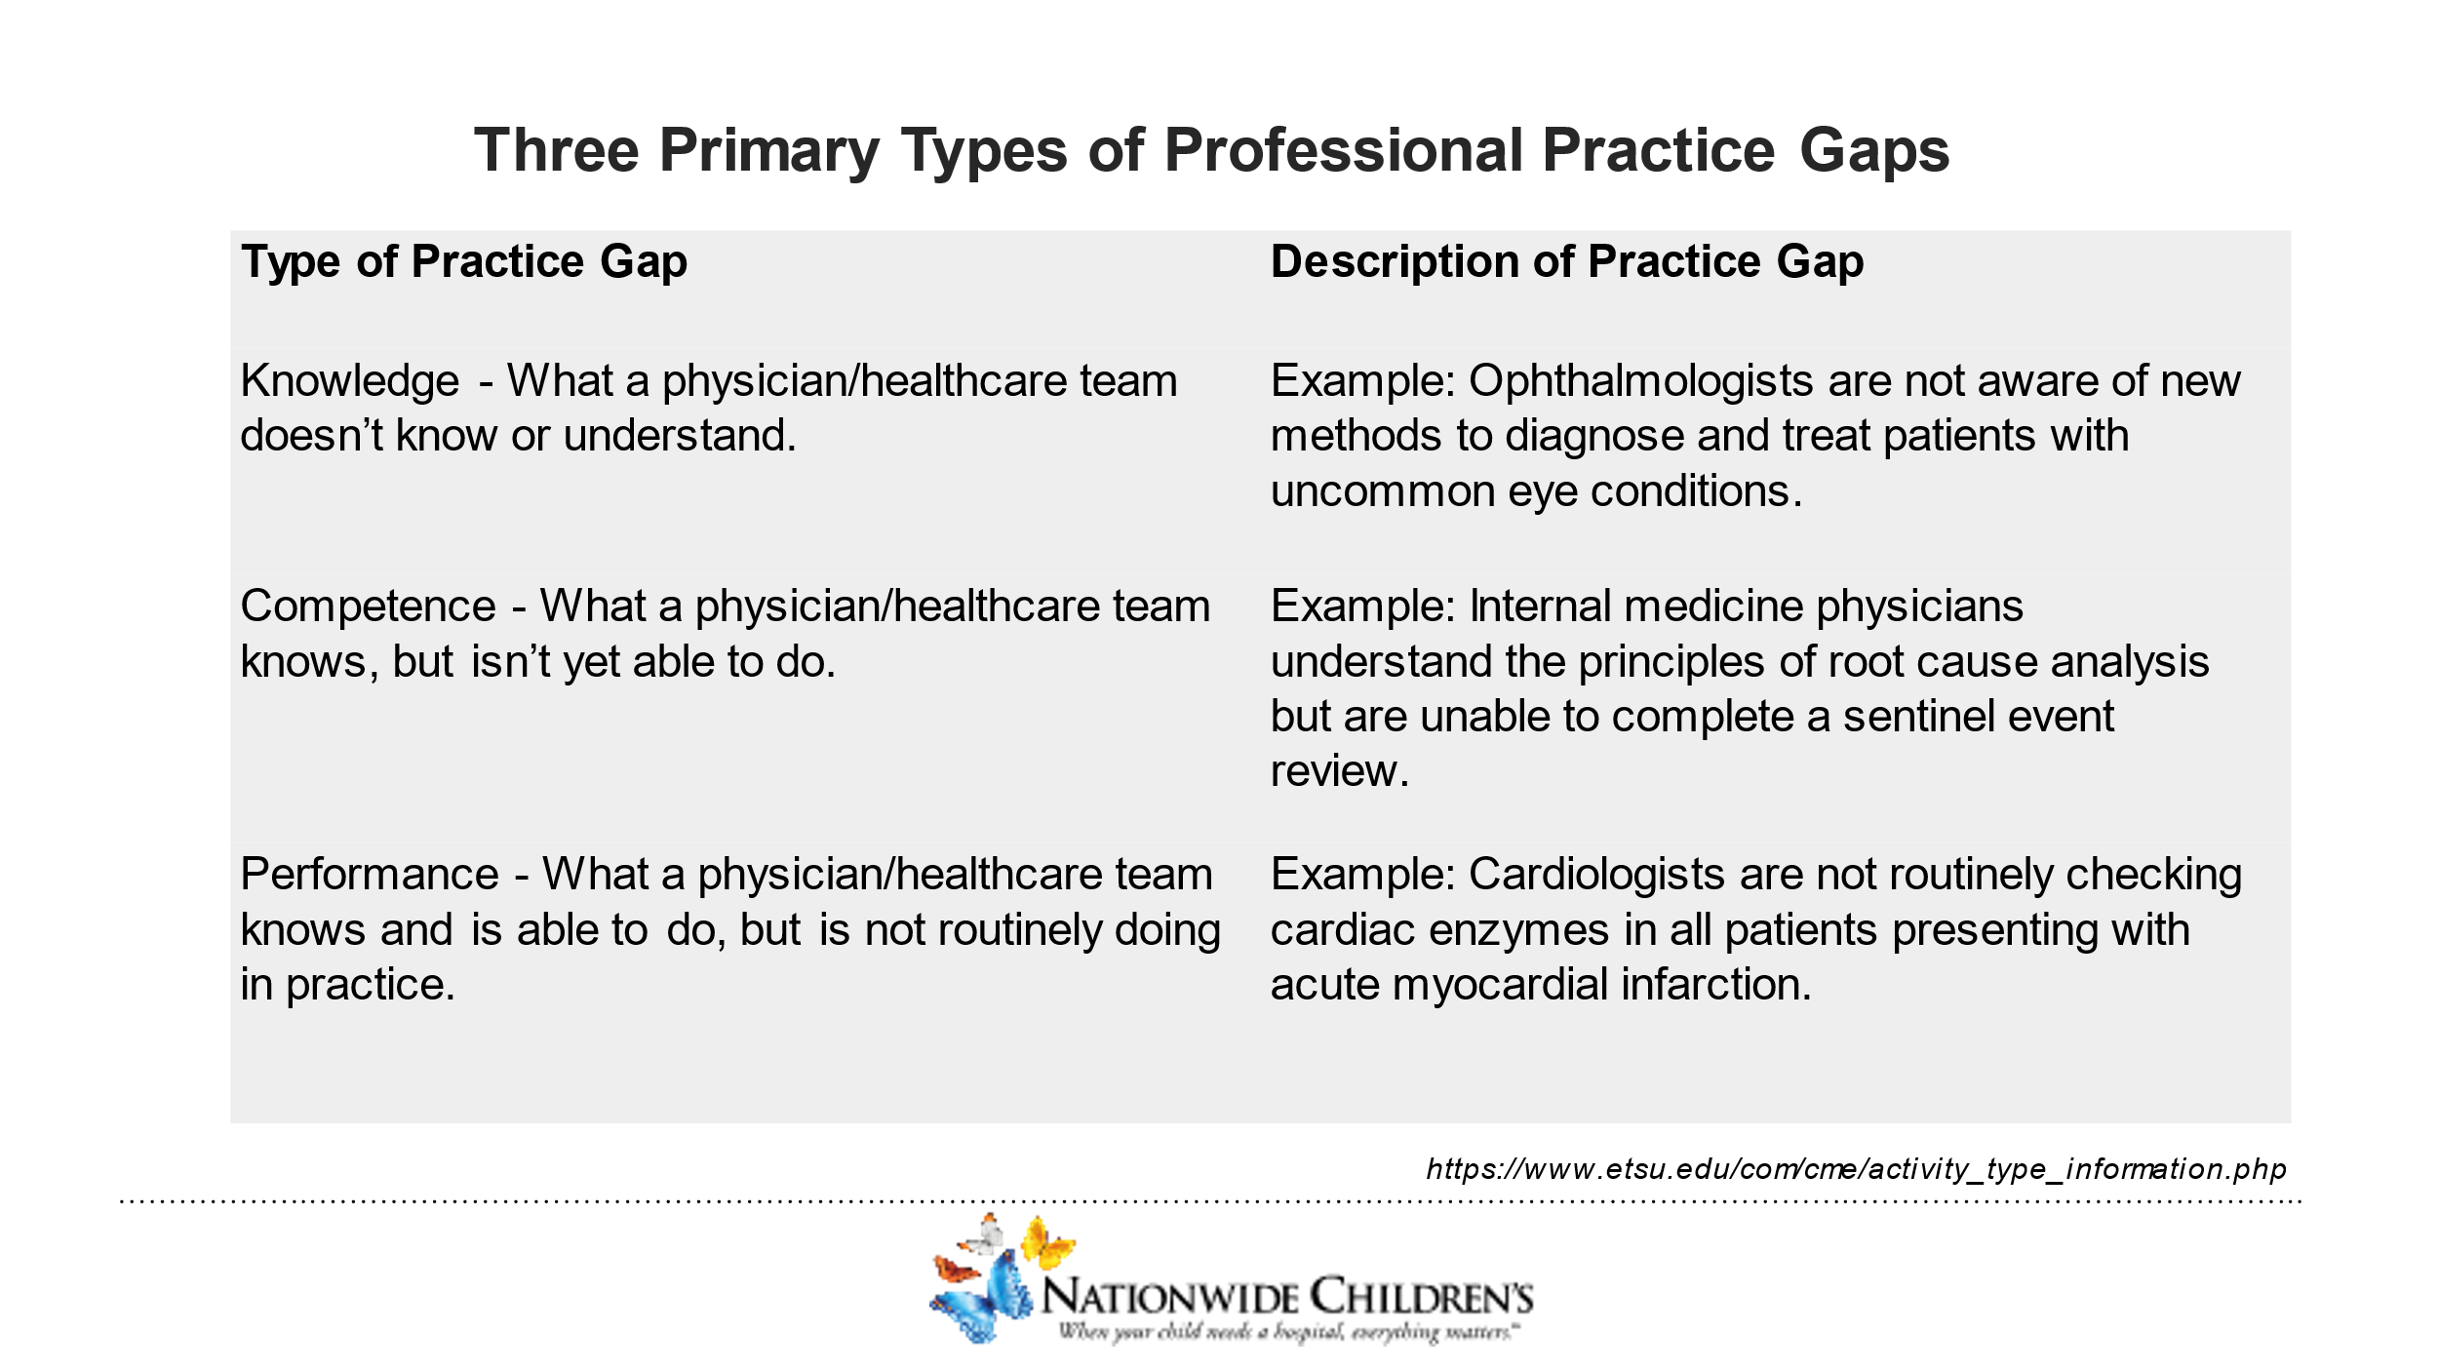

Education needs identified – must be more than knowledge need

Knowledge need details completed – “does not know how”

Skills/Strategy (competence) need details completed – “knows how but isn’t able to do”

Performance need details completed – “knows and is able to do but is not doing”

Designed to change section completed – what, why and how will you measure success

Planned using a process *reflective of the target audience* for the activity section completed (JAC4)

Promotes active learning for the healthcare team completed

Non-educational interventions (If yes, describe) i.e. supporting materials in addition to the live education such as badge buddies, placards, signs, auto-generated reminders, required checklists, etc.)

Needs Assessment (at least one box checked) – supporting documentation uploaded to “Documents” tab.

Barriers (either “No” or items checked) – There really should be something checked here. For example, if participants know how to do something but are not doing it, then there is a barrier that is keeping them from performing. Identifying the barriers are the first step to practice improvement.

**Objectives, Learning Outcomes and Competencies**

Objectives listed (2-3/hour of content)

Objectives measurable (what will participants be able to do as a result of the educational intervention; not what the speaker intends to do). Go beyond remembering and understanding to applying what they will learn. See Bloom’s Taxonomy

*Action verbs to use: Incorporate, Adjust, Analyze, Interpret, Implement*

*Action verbs not to use: Understand, List, Recite, Describe, Learn*

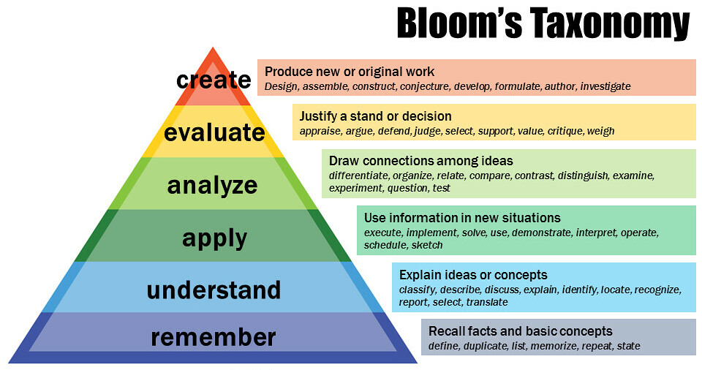

**By Vanderbilt University Center for Teaching - https://www.flickr.com/photos/vandycft/29428436431, CC BY 2.0, https://commons.wikimedia.org/w/index.php?curid=96306577**

**Outcomes**

Knowledge/Competence – at least one box checked.

Performance in Practice – at least one box checked

**Commercial Support**

If yes, letter of agreement required; contact IPCE Program Coordinator for next steps

**JA CRITERIA**

Activity Planning and Evaluation

The following criteria outline the expectations for interprofessional continuing education (IPCE) activities. If the activity is planned for a single profession or multiple professions, but not IPCE, then the criteria would be fulfilled by considering the single profession or target audience. Example: If the activity is designed for nurses only, then the provider would incorporate the educational needs that underlie the practice gaps of nurses.

JAC 4

The provider incorporates into IPCE activities the educational needs (knowledge, skills/strategy, or performance) that underlie the practice gaps of the healthcare team and/or the individual members’ knowledge, skills/strategy, or performance as members of the healthcare team.

JAC 5

The provider generates activities/educational interventions that are designed to change the skills/strategy, or performance of the healthcare team, and/or patient outcomes as described in its mission statement.

JAC 6

OLD: The provider generates activities/educational interventions around valid content that meets the expectations set by Joint Accreditation.

Effective 7/20/23: The provider utilizes an integrated planning process that includes health care professionals who are reflective of the target audience the activity is designed to address.

JAC 7

The provider designs education that promotes active learning – so that teams learn from, with, and about each other – consistent with the desired results of the activity.

JAC 8

The provider develops activities/educational interventions in the context of desirable attributes of the healthcare team (e.g., Institute of Medicine competencies, professional competencies, healthcare team competencies: values/ethics, roles and responsibilities, interprofessional communication, teams and teamwork).

JAC 9

The provider utilizes support strategies to sustain change as an adjunct to its educational interventions (e.g., reminders, patient feedback).

JAC 10

The provider implements strategies to remove, overcome, or address barriers to change in the skills/strategy or performance of the healthcare team.

JAC 11

The provider analyzes changes in the healthcare team (skills/strategy, performance) and/or patient outcomes achieved as a result of its IPCE activities/educational interventions.

Integrity and Independence

The following criterion outlines the expectations for ensuring that accredited continuing education serves the needs of patients and the public; presents learners with only accurate, balanced, scientifically justified recommendations; assures learners they can trust accredited continuing education to help them deliver, safe, effective, cost-effective, and compassionate care that is based on best practice and evidence; and creates a clear, unbridgeable separation between accredited continuing education and marketing and sales.

JAC 12

The provider develops activities/interventions that comply with the Standards for Integrity and Independence in Accredited Continuing Education, which includes the responsibility to:

a. Ensure content is valid.

b. Prevent commercial bias and marketing in accredited continuing education.

c. Identify, mitigate, and disclose relevant financial relationships.

d. Manage commercial support appropriately (if applicable).

e. Manage ancillary activities offered in conjunction with accredited continuing education (if applicable).