Activity Name:
- 2026 Pediatric Grand Rounds on Demand

Date & Time:
- April 23, 2026 - 12:00 AM

Presentation Title:
- 2026 PGROD - Winning Through Chaos: How Crises Accelerated Our Quality and Safety Journey by Paul Sharek, MD, MPH

Speakers & Planners Information:

Name of individual | Individual's role in activity | Nature of Relationship(s) / Name of Ineligible Company(s)
Liz Bonachea, MD | Other Planning Committee Member | Nothing to disclose - 10/27/2025
Debra Boyer, MD | Other Planning Committee Member | Nothing to disclose - 09/30/2025
Amy Garee, NP | Other Planning Committee Member | Nothing to disclose - 08/14/2025
Kelly Hallberg, MBA | Other Planning Committee Member | Nothing to disclose - 01/06/2026
Jenna Hatab, MD | Other Planning Committee Member | Nothing to disclose - 10/26/2025
Kristina Jiner, MD | Other Planning Committee Member | Nothing to disclose - 12/08/2025
Leah LaLonde, PhD | Other Planning Committee Member | Nothing to disclose - 03/12/2026
Tina Lepley, ATC | Other Planning Committee Member | Nothing to disclose - 01/13/2026
BENJAMIN LEVINSON, MD | Other Planning Committee Member | Nothing to disclose - 10/16/2025
Nancy Liao, MD | Other Planning Committee Member | Honoraria-Elsevier (Relationship has ended)|Honoraria-Springer - 10/13/2025
Susi Miller, MLIS | Other Planning Committee Member | Nothing to disclose - 10/16/2025
Julia Muehl, BA | Activity Administrator | Nothing to disclose - 01/16/2026
Leena Nahata, MD | Other Planning Committee Member | Grant or research support-National Institutes of Health|Consulting Fee-Worth the Wait nonprofit (Relationship has ended) - 09/26/2025
Jason Newland, MD | Other Planning Committee Member | Grant or research support-Merck (Relationship has ended)|Grant or research support-Pfizer (Relationship has ended) - 06/13/2025
Kehinde Obeto, md | Other Planning Committee Member | Nothing to disclose - 10/07/2025
Sarah OBrien, MD | Other Planning Committee Member | Membership on Advisory Committees or Review Panels, Board Membership, etc.-iECURE|Advisor-Hemab|Consulting Fee-AstraZeneca (Relationship has ended) - 10/11/2025
Whitney Phillips, Other | Activity Coordinator | Nothing to disclose - 02/26/2026
Marcie Rehmar-Rogell, MS | Other Planning Committee Member | Nothing to disclose - 09/26/2025
Matthew Sapko , Chief Pharmacy Officer | Other Planning Committee Member | Nothing to disclose - 10/20/2025
Paul Sharek, MD, MPH | Faculty | Nothing to disclose - 04/18/2026
Julia R Tibor, BA | Activity Coordinator | Nothing to disclose - 02/02/2026

Session Objectives:

1 Assess how major crises can actually accelerate a hospital’s quality and safety improvement efforts.
2 Identify key metrics for tracking quality and safety in the midst of institutional crises.
3 Outline leadership strategies that transform crises into opportunities for quality and safety enhancements.


In support of improving patient care, Nationwide Children’s hospital is jointly accredited by the American Nurses Credentialing Center (ANCC), the Accreditation Council for Pharmacy Education (ACPE), and the Accreditation Council for Continuing Medical Education (ACCME) to provide continuing medical education for the healthcare team. (1.00 ANCC contact hour(s))

(1.00 AMA PRA Category 1 CME Credit(s)™)

The Nationwide Children's Hospital designates this enduring material for a maximum of 1.00 AMA PRA Category 1 Credit(s)TM. Physicians should claim only the credit commensurate with the extent of their participation in the activity.



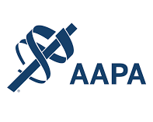

Nationwide Children's Hospital has been authorized by the American Academy of PAs (AAPA) to award AAPA Category 1 CME credit for activities planned in accordance with AAPA CME Criteria. This activity is designated for 1.00 AAPA Category 1 CME credit(s). Approval is valid for 2 years from the date of the activity. PAs should only claim credit commensurate with the extent of their participation.





Continuing Education (CE) credits for psychologists are provided through the co-sponsorship of the American Psychological Association (APA) Office of Continuing Education in Psychology (CEP). The APA CEP Office maintains responsibility for the content of the programs. Nationwide Children's Hospital designates this activity for 1.00 continuing education credit(s).
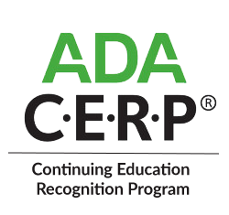

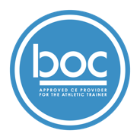


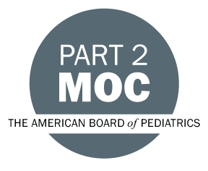

Disclosure of Relevant Financial Relationships and Content Validity

It is policy at Nationwide Children’s Hospital Office of Continuing Medical and Interprofessional Education for individuals who are in a position to control the content of an educational activity to disclose to the learners all relevant financial relationships that they have with any commercial interest that provide products or services that may be relevant to the content of this continuing education activity.

The intent of this policy is to ensure that Nationwide Children’s Hospital CME/CE certified activities promote quality and safety, are effective in improving medical practice, are based on valid content, and are independent of control from ineligible companies (those whose primary business is producing, marketing, selling, re-selling, or distributing healthcare products used by or on patients) and free of commercial bias. Mitigation methods including peer review of all content was conducted for all faculty presentations whose disclosure information was found to contain relationships that created a conflict of interest relevant to the topic of their presentation.

In addition, all faculty were instructed to provide balanced, scientifically rigorous and evidence-based presentations. All recommendations for patient care in accredited continuing education must be based on current science, evidence, and clinical reasoning, while giving a fair and balanced view of diagnostic and therapeutic options. All scientific research referred to, reported, or used in accredited education in support or justification of a patient care recommendation must conform to the generally accepted standards of experimental design, data collection, analysis, and interpretation.

IPCE Program DOCUMENT Vers. 2; 1.6.2022

