Activity Name:
- BH Education: An Introduction to Healthy Conversation Skills Home Study (#54799)

Date & Time:
- April 20, 2026 - 8:00 AM

Speakers & Planners Information:

Name of individual | Individual's role in activity | Nature of Relationship(s) / Name of Ineligible Company(s)
Eileen A Chaves, PhD | Faculty, Other Planning Committee Member | Honoraria-Obesity Medicine Association (Relationship has ended) - 12/09/2025
Amrik Khalsa, MD | Faculty, Other Planning Committee Member | Nothing to disclose - 12/03/2025

Session Objectives:

1 Define Healthy Conversation Skills (HCS) and the mental health provider’s role in behavior change counseling.
2 Understand and identify the core principles of (HCS).
3 Explore key skills of HCS including asking open discovery questions, listening more than talking, and reflecting on practice.
4 Improve communication and collaboration among the healthcare team through shared decision making.

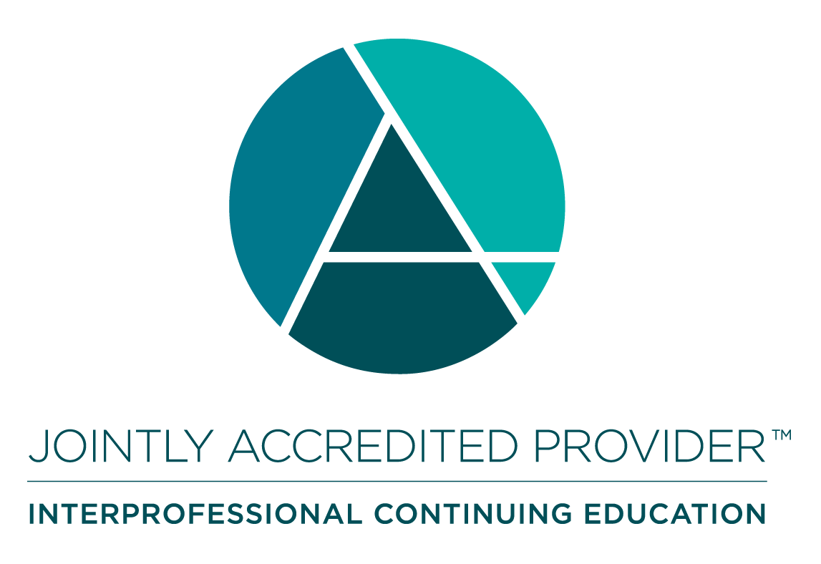
In support of improving patient care, Nationwide Children’s hospital is jointly accredited by the American Nurses Credentialing Center (ANCC), the Accreditation Council for Pharmacy Education (ACPE), and the Accreditation Council for Continuing Medical Education (ACCME) to provide continuing medical education for the healthcare team.

(1.00 AMA PRA Category 1 CME Credit(s)™)

The Nationwide Children's Hospital designates this enduring material for a maximum of 1.00 AMA PRA Category 1 Credit(s)TM. Physicians should claim only the credit commensurate with the extent of their participation in the activity.

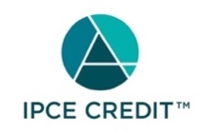

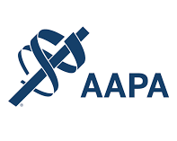



As a Jointly Accredited Organization, Nationwide Children's Hospital is approved to offer social work continuing education by the Association of Social Work Boards (ASWB) Approved Continuing Education (ACE) program. Organizations, not individual courses, are approved under this program. State and provincial regulatory boards have the final authority to determine whether an individual course may be accepted for continuing education credit. Nationwide Children's Hospital maintains responsibility for this course. Social workers completing this course receive 1.00 continuing education credit(s).



Continuing Education (CE) credits for psychologists are provided through the co-sponsorship of the American Psychological Association (APA) Office of Continuing Education in Psychology (CEP). The APA CEP Office maintains responsibility for the content of the programs. Nationwide Children's Hospital designates this activity for 1.00 continuing education credit(s).
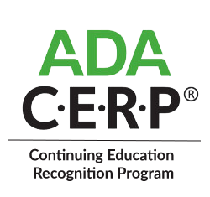

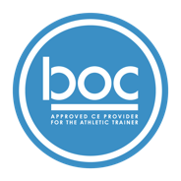

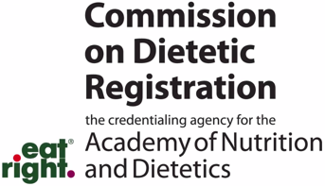
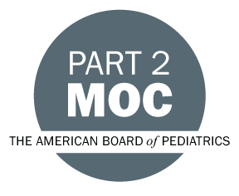

Disclosure of Relevant Financial Relationships and Content Validity

It is policy at Nationwide Children’s Hospital Office of Continuing Medical and Interprofessional Education for individuals who are in a position to control the content of an educational activity to disclose to the learners all relevant financial relationships that they have with any commercial interest that provide products or services that may be relevant to the content of this continuing education activity.

The intent of this policy is to ensure that Nationwide Children’s Hospital CME/CE certified activities promote quality and safety, are effective in improving medical practice, are based on valid content, and are independent of control from ineligible companies (those whose primary business is producing, marketing, selling, re-selling, or distributing healthcare products used by or on patients) and free of commercial bias. Mitigation methods including peer review of all content was conducted for all faculty presentations whose disclosure information was found to contain relationships that created a conflict of interest relevant to the topic of their presentation.

In addition, all faculty were instructed to provide balanced, scientifically rigorous and evidence-based presentations. All recommendations for patient care in accredited continuing education must be based on current science, evidence, and clinical reasoning, while giving a fair and balanced view of diagnostic and therapeutic options. All scientific research referred to, reported, or used in accredited education in support or justification of a patient care recommendation must conform to the generally accepted standards of experimental design, data collection, analysis, and interpretation.

IPCE Program DOCUMENT Vers. 2; 1.6.2022

