Activity Name:
- 2026 Partners for Kids-Behavioral Health Community Education Series (#48571)

Date & Time:
- October 9, 2026 - 9:00 AM

Presentation Title:
- The Practice of Ethical and Responsible Reporting of Suspected Abuse and Neglect (#48581) **CSWMFT & OPA Ethics**

Speakers & Planners Information:

Name of individual | Individual's role in activity | Nature of Relationship(s) / Name of Ineligible Company(s)
Taylor Adams | Other Planning Committee Member
Allison DePoy, LISW-S | Faculty, Other Planning Committee Member | Nothing to disclose - 03/09/2026
Patrick Frueh, MOD | Other Planning Committee Member | Nothing to disclose - 12/18/2025
Anna J Kerlek, MD | Other Planning Committee Member | Nothing to disclose - 01/21/2026
Susan Orme, MSN | Other Planning Committee Member
Ashley Skelly, LPCC-S | Faculty | Nothing to disclose - 01/21/2026
Yvonne Staton, MEd | Activity Coordinator | Nothing to disclose - 01/23/2026
Karen B Tabern, PsyD | Faculty | Nothing to disclose - 07/08/2026

Session Objectives:

1 Summarize their obligations as mandated reporters of suspected abuse and neglect
2 List 1-2 available resources for consultation related to reporting and documenting suspected abuse and neglect
3 Document responsibly their professional concerns related to suspected abuse and neglect in the clinical chart
4 Define the following: suspected, The Ohio Revised Code, Abuse, Neglect, Sexual Abuse, Physical Abuse, emotional abuse
5 Demonstrate effective communication strategies to enhance interdisciplinary collaboration and patient care outcomes

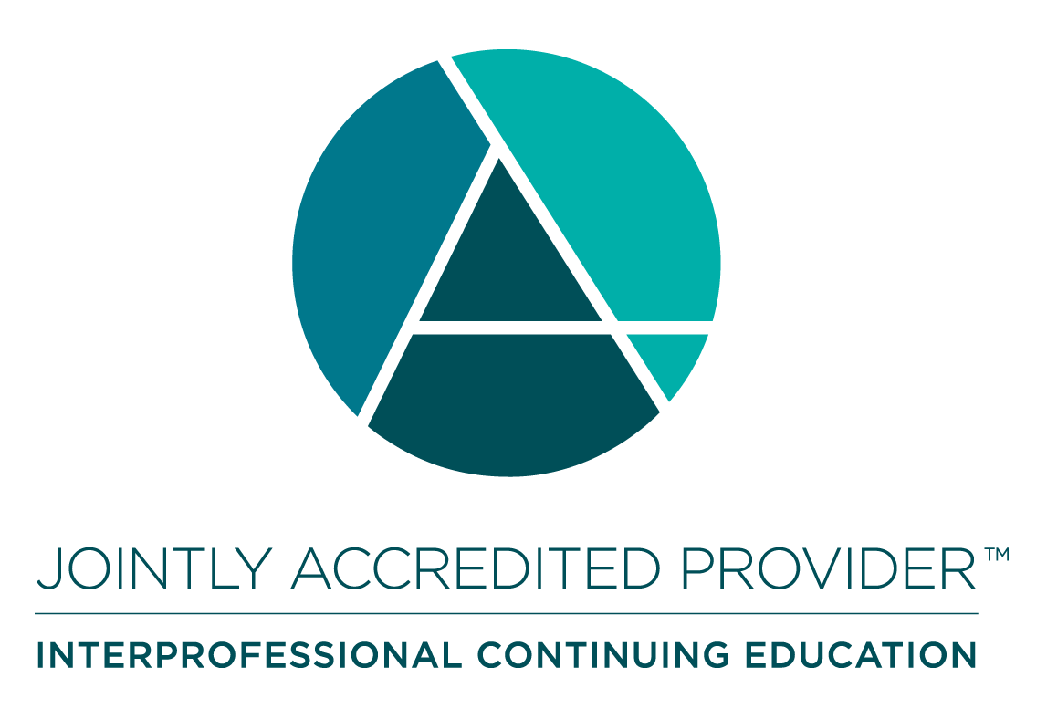
In support of improving patient care, Nationwide Children’s hospital is jointly accredited by the American Nurses Credentialing Center (ANCC), the Accreditation Council for Pharmacy Education (ACPE), and the Accreditation Council for Continuing Medical Education (ACCME) to provide continuing medical education for the healthcare team. (3.00 ANCC contact hour(s))

(3.00 AMA PRA Category 1 CME Credit(s)™)

The Nationwide Children's Hospital designates this live activity for a maximum of 3.00 AMA PRA Category 1 Credit(s)TM. Physicians should claim only the credit commensurate with the extent of their participation in the activity.

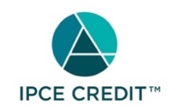

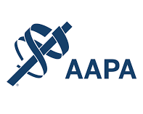

Nationwide Children's Hospital has been authorized by the American Academy of PAs (AAPA) to award AAPA Category 1 CME credit for activities planned in accordance with AAPA CME Criteria. This activity is designated for 3.00 AAPA Category 1 CME credit(s). Approval is valid for 2 years from the date of the activity. PAs should only claim credit commensurate with the extent of their participation.



As a Jointly Accredited Organization, Nationwide Children's Hospital is approved to offer social work continuing education by the Association of Social Work Boards (ASWB) Approved Continuing Education (ACE) program. Organizations, not individual courses, are approved under this program. State and provincial regulatory boards have the final authority to determine whether an individual course may be accepted for continuing education credit. Nationwide Children's Hospital maintains responsibility for this course. Social workers completing this course receive 3.00 continuing education credit(s).



Continuing Education (CE) credits for psychologists are provided through the co-sponsorship of the American Psychological Association (APA) Office of Continuing Education in Psychology (CEP). The APA CEP Office maintains responsibility for the content of the programs. Nationwide Children's Hospital designates this activity for 3.00 continuing education credit(s).
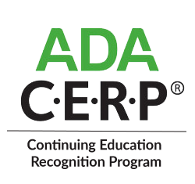

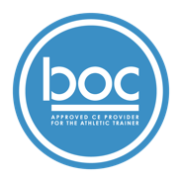

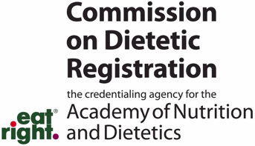
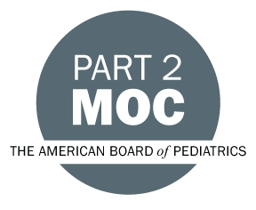

Disclosure of Relevant Financial Relationships and Content Validity

It is policy at Nationwide Children’s Hospital Office of Continuing Medical and Interprofessional Education for individuals who are in a position to control the content of an educational activity to disclose to the learners all relevant financial relationships that they have with any commercial interest that provide products or services that may be relevant to the content of this continuing education activity.

The intent of this policy is to ensure that Nationwide Children’s Hospital CME/CE certified activities promote quality and safety, are effective in improving medical practice, are based on valid content, and are independent of control from ineligible companies (those whose primary business is producing, marketing, selling, re-selling, or distributing healthcare products used by or on patients) and free of commercial bias. Mitigation methods including peer review of all content was conducted for all faculty presentations whose disclosure information was found to contain relationships that created a conflict of interest relevant to the topic of their presentation.

In addition, all faculty were instructed to provide balanced, scientifically rigorous and evidence-based presentations. All recommendations for patient care in accredited continuing education must be based on current science, evidence, and clinical reasoning, while giving a fair and balanced view of diagnostic and therapeutic options. All scientific research referred to, reported, or used in accredited education in support or justification of a patient care recommendation must conform to the generally accepted standards of experimental design, data collection, analysis, and interpretation.

IPCE Program DOCUMENT Vers. 2; 1.6.2022

