Activity Name:
- Making Changes in My Corner of the World: The Spectrum of Advocacy: A CDC Committee for Social Change Intensive Home Study (#48549) **CSWMFT Ethics**OPA-MCE Cultural Competency**

Date & Time:
- December 12, 2025 - 8:00 AM

Speakers & Planners Information:

Name of individual | Individual's role in activity | Nature of Relationship(s) / Name of Ineligible Company(s)
Elizabeth Barnhardt, DO | Faculty, Other Planning Committee Member | Nothing to disclose - 12/16/2024
Jennifer Cervantes, MSW, LSW, Assistant Professor | Faculty, Other Planning Committee Member | Nothing to disclose - 11/07/2025
Aileen Collins, Other, MPA | Other Planning Committee Member | Nothing to disclose - 10/20/2025
Cody Hostutler, PhD | Faculty, Other Planning Committee Member | Royalties or Patent Beneficiary-American Academy of Pediatrics - 07/31/2025
Daniel Hurley, BA | Faculty | Nothing to disclose - 10/21/2025
Elizabeth Kryszak, PhD | Other Planning Committee Member | Nothing to disclose - 10/14/2025
Dustin J. McKee, MSW, Chief Executive Officer | Other Planning Committee Member | Nothing to disclose - 10/20/2025
Charles Solley, MPA | Other Planning Committee Member | Nothing to disclose - 09/23/2025

Session Objectives:

1 Define Mental Health Advocacy: Explain what advocacy means in the context of mental health (e.g., speaking up, supporting policy changes, reducing stigma, etc.).
2 Highlight the Role of Policy and Systems: Discuss how laws, workplace policies, and public services impact mental health access and outcomes.
3 Encourage Action: Participants will write at least on concrete step they can take toward advocating—such as joining campaigns, supporting mental health organizations, or starting conversations in their communities.
4 Demonstrate effective communication strategies to enhance interdisciplinary collaboration


In support of improving patient care, Nationwide Children’s hospital is jointly accredited by the American Nurses Credentialing Center (ANCC), the Accreditation Council for Pharmacy Education (ACPE), and the Accreditation Council for Continuing Medical Education (ACCME) to provide continuing medical education for the healthcare team.

(1.75 AMA PRA Category 1 CME Credit(s)™)

The Nationwide Children's Hospital designates this enduring material for a maximum of 1.75 AMA PRA Category 1 Credit(s)TM. Physicians should claim only the credit commensurate with the extent of their participation in the activity.

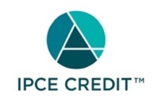

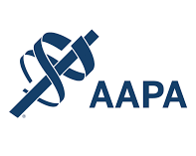



As a Jointly Accredited Organization, Nationwide Children's Hospital is approved to offer social work continuing education by the Association of Social Work Boards (ASWB) Approved Continuing Education (ACE) program. Organizations, not individual courses, are approved under this program. State and provincial regulatory boards have the final authority to determine whether an individual course may be accepted for continuing education credit. Nationwide Children's Hospital maintains responsibility for this course. Social workers completing this course receive 1.75 continuing education credit(s).



Continuing Education (CE) credits for psychologists are provided through the co-sponsorship of the American Psychological Association (APA) Office of Continuing Education in Psychology (CEP). The APA CEP Office maintains responsibility for the content of the programs. Nationwide Children's Hospital designates this activity for 1.75 continuing education credit(s).
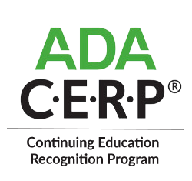

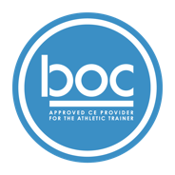

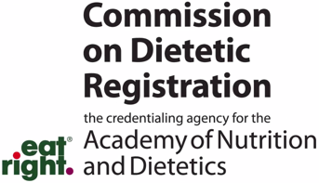
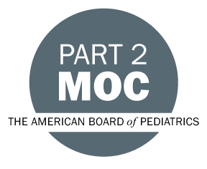

Disclosure of Relevant Financial Relationships and Content Validity

It is policy at Nationwide Children’s Hospital Office of Continuing Medical and Interprofessional Education for individuals who are in a position to control the content of an educational activity to disclose to the learners all relevant financial relationships that they have with any commercial interest that provide products or services that may be relevant to the content of this continuing education activity.

The intent of this policy is to ensure that Nationwide Children’s Hospital CME/CE certified activities promote quality and safety, are effective in improving medical practice, are based on valid content, and are independent of control from ineligible companies (those whose primary business is producing, marketing, selling, re-selling, or distributing healthcare products used by or on patients) and free of commercial bias. Mitigation methods including peer review of all content was conducted for all faculty presentations whose disclosure information was found to contain relationships that created a conflict of interest relevant to the topic of their presentation.

In addition, all faculty were instructed to provide balanced, scientifically rigorous and evidence-based presentations. All recommendations for patient care in accredited continuing education must be based on current science, evidence, and clinical reasoning, while giving a fair and balanced view of diagnostic and therapeutic options. All scientific research referred to, reported, or used in accredited education in support or justification of a patient care recommendation must conform to the generally accepted standards of experimental design, data collection, analysis, and interpretation.

IPCE Program DOCUMENT Vers. 2; 1.6.2022

