Activity Name:
- Nursing Grand Rounds Enduring

Date & Time:
- October 14, 2025 - 7:00 AM

Presentation Title:
- 2025 Nursing Grand Rounds McKissick Health Equity Lectureship Series: Enduring October 14: Parent Presence and Participation in Caregiving in the NICU

Speakers & Planners Information:

Name of individual | Individual's role in activity | Nature of Relationship(s) / Name of Ineligible Company(s)
Courtney Bishop, PA-C | Other Planning Committee Member | Nothing to disclose - 09/10/2025
Susan Copeland, RN, MS, NPD-BC, PED-BC | Activity Coordinator | Nothing to disclose - 11/21/2024
Lauren Fairchild, MSN, RN, NPD-BC | Activity Coordinator | Nothing to disclose - 07/30/2025
Lindsey Glaze, PharmD | Other Planning Committee Member | Nothing to disclose - 09/16/2025
Marliese D Nist , PhD, RNC-NIC | Faculty | Nothing to disclose - 08/28/2025
Rita Pickler, PhD, RN | Faculty | Nothing to disclose - 08/28/2025

Session Objectives:

1 Examine the role of parents in NICU caregiving and the importance of parent presence for optimizing infant outcomes.
2 Describe the known barriers and facilitators of parent presence and participation in caregiving in the NICU and evaluate the strengths and limitations of available data.
3 Apply Andersen's Behavioral Model of Health Services Use to understand the influences of parent presence and participation.
4 Describe a comprehensive study to systematically examine the barriers and facilitators of parent presence and participation and their effects on infant outcomes.


In support of improving patient care, Nationwide Children’s hospital is jointly accredited by the American Nurses Credentialing Center (ANCC), the Accreditation Council for Pharmacy Education (ACPE), and the Accreditation Council for Continuing Medical Education (ACCME) to provide continuing medical education for the healthcare team. (1.00 ANCC contact hour(s))

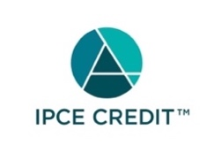

This activity was planned by and for the healthcare team, and learners will receive 1.00 Interprofessional Continuing Education (IPCE) credit(s) for learning and change.

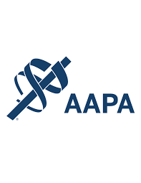

Nationwide Children's Hospital has been authorized by the American Academy of PAs (AAPA) to award AAPA Category 1 CME credit for activities planned in accordance with AAPA CME Criteria. This activity is designated for 1.00 AAPA Category 1 CME credit(s). Approval is valid for 2 years from the date of the activity. PAs should only claim credit commensurate with the extent of their participation.




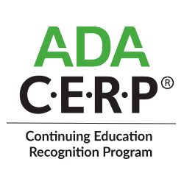

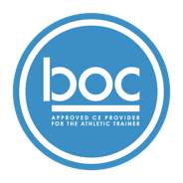

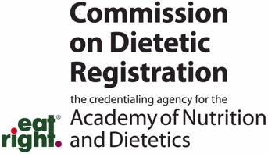
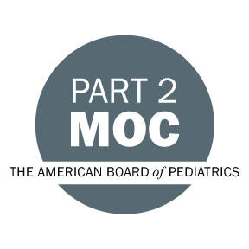

Disclosure of Relevant Financial Relationships and Content Validity

It is policy at Nationwide Children’s Hospital Office of Continuing Medical and Interprofessional Education for individuals who are in a position to control the content of an educational activity to disclose to the learners all relevant financial relationships that they have with any commercial interest that provide products or services that may be relevant to the content of this continuing education activity.

The intent of this policy is to ensure that Nationwide Children’s Hospital CME/CE certified activities promote quality and safety, are effective in improving medical practice, are based on valid content, and are independent of control from ineligible companies (those whose primary business is producing, marketing, selling, re-selling, or distributing healthcare products used by or on patients) and free of commercial bias. Mitigation methods including peer review of all content was conducted for all faculty presentations whose disclosure information was found to contain relationships that created a conflict of interest relevant to the topic of their presentation.

In addition, all faculty were instructed to provide balanced, scientifically rigorous and evidence-based presentations. All recommendations for patient care in accredited continuing education must be based on current science, evidence, and clinical reasoning, while giving a fair and balanced view of diagnostic and therapeutic options. All scientific research referred to, reported, or used in accredited education in support or justification of a patient care recommendation must conform to the generally accepted standards of experimental design, data collection, analysis, and interpretation.

IPCE Program DOCUMENT Vers. 2; 1.6.2022

