Activity Name:
- 2025 Pediatric Grand Rounds On Demand

Date & Time:
- September 11, 2025 - 12:00 AM

Presentation Title:
- 2025 PGROD: Optimizing the Medical Home: Clinical Informatics for Interoperability & Better Patient Care by Shravani Vundavalli, MD, Shama Patel, MD, MPH, and Alysha Taxter, MD

Speakers & Planners Information:

Name of individual | Individual's role in activity | Nature of Relationship(s) / Name of Ineligible Company(s)
Kelly Hallberg, MBA | Other Planning Committee Member | Nothing to disclose - 12/05/2024
Jennifer Weiner, DNP | Other Planning Committee Member | Nothing to disclose - 04/10/2025
Susi Miller, MLIS | Other Planning Committee Member | Nothing to disclose - 04/28/2025
Christine Koterba, PhD | Other Planning Committee Member | Nothing to disclose - 10/23/2024
Marcie Rehmar-Rogell, MS | Other Planning Committee Member | Nothing to disclose - 10/01/2024
Matthew Sapko , Chief Pharmacy Officer | Other Planning Committee Member | Nothing to disclose - 11/11/2024
Jennifer Reese, PsyD | Other Planning Committee Member | Nothing to disclose - 09/30/2024
Leena Nahata, MD | Other Planning Committee Member | Grant or research support-National Institutes of Health|Consulting Fee-Worth the Wait nonprofit (Relationship has ended) - 10/02/2024
Liz Bonachea, MD | Other Planning Committee Member | Nothing to disclose - 08/14/2025
Tahagod Mohamed, MD | Other Planning Committee Member | Nothing to disclose - 02/18/2025
BENJAMIN LEVINSON, MD | Other Planning Committee Member | Nothing to disclose - 10/18/2024
Debra Boyer, MD | Other Planning Committee Member | Nothing to disclose - 10/02/2024
Emily Ernest, MD | Other Planning Committee Member | Nothing to disclose - 10/08/2024
Sofia Davila, MD | Other Planning Committee Member | Nothing to disclose - 01/22/2025
Heather Meade, MD, MD | Other Planning Committee Member | Nothing to disclose - 01/07/2025

Session Objectives:

1 Describe the role of health information technology in the Medical Home model.
2 Identify challenges and solutions for data-sharing across pediatric care settings.
3 Evaluate the impact of clinical informatics tools on both patient outcomes and provider efficiency.


In support of improving patient care, Nationwide Children’s hospital is jointly accredited by the American Nurses Credentialing Center (ANCC), the Accreditation Council for Pharmacy Education (ACPE), and the Accreditation Council for Continuing Medical Education (ACCME) to provide continuing medical education for the healthcare team. (1.00 ANCC contact hour(s)) (1.00 ACPE contact hour(s))

(1.00 AMA PRA Category 1 CME Credit(s)™)

The Nationwide Children's Hospital designates this enduring material for a maximum of 1.00 AMA PRA Category 1 Credit(s)TM. Physicians should claim only the credit commensurate with the extent of their participation in the activity.

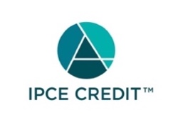

This activity was planned by and for the healthcare team, and learners will receive 1.00 Interprofessional Continuing Education (IPCE) credit(s) for learning and change.



Nationwide Children's Hospital has been authorized by the American Academy of PAs (AAPA) to award AAPA Category 1 CME credit for activities planned in accordance with AAPA CME Criteria. This activity is designated for 1.00 AAPA Category 1 CME credit(s). Approval is valid for 2 years from the date of the activity. PAs should only claim credit commensurate with the extent of their participation.





Continuing Education (CE) credits for psychologists are provided through the co-sponsorship of the American Psychological Association (APA) Office of Continuing Education in Psychology (CEP). The APA CEP Office maintains responsibility for the content of the programs. Nationwide Children's Hospital designates this activity for 1.00 continuing education credit(s).
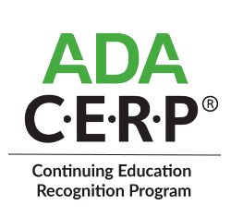

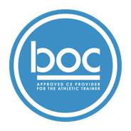


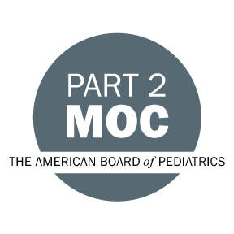

Disclosure of Relevant Financial Relationships and Content Validity

It is policy at Nationwide Children’s Hospital Office of Continuing Medical and Interprofessional Education for individuals who are in a position to control the content of an educational activity to disclose to the learners all relevant financial relationships that they have with any commercial interest that provide products or services that may be relevant to the content of this continuing education activity.

The intent of this policy is to ensure that Nationwide Children’s Hospital CME/CE certified activities promote quality and safety, are effective in improving medical practice, are based on valid content, and are independent of control from ineligible companies (those whose primary business is producing, marketing, selling, re-selling, or distributing healthcare products used by or on patients) and free of commercial bias. Mitigation methods including peer review of all content was conducted for all faculty presentations whose disclosure information was found to contain relationships that created a conflict of interest relevant to the topic of their presentation.

In addition, all faculty were instructed to provide balanced, scientifically rigorous and evidence-based presentations. All recommendations for patient care in accredited continuing education must be based on current science, evidence, and clinical reasoning, while giving a fair and balanced view of diagnostic and therapeutic options. All scientific research referred to, reported, or used in accredited education in support or justification of a patient care recommendation must conform to the generally accepted standards of experimental design, data collection, analysis, and interpretation.

IPCE Program DOCUMENT Vers. 2; 1.6.2022

