Activity Name:
- Primary Care Education Series

Date & Time:
- October 9, 2025 - 5:00 PM

Presentation Title:
- Primary Care Education Series - Pain in Children: A Primary Care Approach for Evaluation/Management

Speakers & Planners Information:

Name of individual | Individual's role in activity | Nature of Relationship(s) / Name of Ineligible Company(s)
Kyla Driest, MD, MEd | Faculty | Nothing to disclose - 11/11/2024
Krista Buckingham, NP | Co-Director | Nothing to disclose - 08/04/2025
Cody Hostutler, PhD | Co-Director | Royalties or Patent Beneficiary-American Academy of Pediatrics - 07/31/2025
Kaitlin L'Italien, MD | Faculty | Nothing to disclose - 05/08/2025
Lindsey Vater, PsyD | Faculty | Paid consultant-Tourette Association of America (Relationship has ended)|Honoraria-Riley Children's Hospital (Relationship has ended) - 03/24/2025
Raul E Sanchez, MD | Faculty | Honoraria-Sanofi (Relationship has ended) - 06/07/2025
Allison Smith, BA | Activity Coordinator | Nothing to disclose - 08/19/2025
Jagadisharaje Urs, MD | Co-Director, Faculty | Nothing to disclose - 07/24/2025
William Long, MD | Co-Director, Faculty | Nothing to disclose - 08/13/2025
Anne Connelly, Physician Liaison | Activity Coordinator | Nothing to disclose - 04/14/2025
Timothy S Crabtree, PharmD | Co-Director | Nothing to disclose - 07/25/2025
Allen Kadado, MD | Faculty | Consulting Fee-OrthoPediatrics - 10/15/2024
Sean A Tabaie, MD, MBA, FAAOS FAOA | Faculty | Paid consultant-Arthrex (Relationship has ended)|Paid consultant-OrthoPediatrics (Relationship has ended)|Paid consultant-Johnson & Johnson (Relationship has ended) - 04/09/2025

Session Objectives:

1 Improve communication and collaboration within the health care team
2 Participants will analyze their level of fidelity with best practices shared by subject matter experts in activity sessions.
3 Identify at least 1 evidence-based change participants can make in their practice based on findings from presented data.


In support of improving patient care, Nationwide Children’s hospital is jointly accredited by the American Nurses Credentialing Center (ANCC), the Accreditation Council for Pharmacy Education (ACPE), and the Accreditation Council for Continuing Medical Education (ACCME) to provide continuing medical education for the healthcare team. (2.00 ANCC contact hour(s)) (2.00 ACPE contact hour(s))

(2.00 AMA PRA Category 1 CME Credit(s)™)

The Nationwide Children's Hospital designates this live activity for a maximum of 2.00 AMA PRA Category 1 Credit(s)TM. Physicians should claim only the credit commensurate with the extent of their participation in the activity.

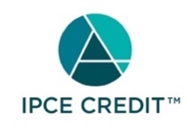







Continuing Education (CE) credits for psychologists are provided through the co-sponsorship of the American Psychological Association (APA) Office of Continuing Education in Psychology (CEP). The APA CEP Office maintains responsibility for the content of the programs. Nationwide Children's Hospital designates this activity for 2.00 continuing education credit(s).
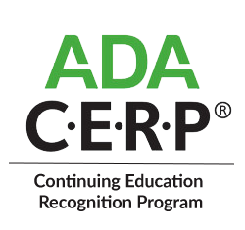

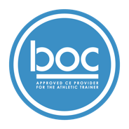


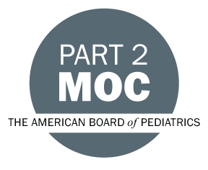

Successful completion of this live CME activity, which includes participation in the activity, with individual assessments of the participant and feedback to the participant enables the participant to earn up to 2.00 MOC points in the American Board of Pediatrics' (ABP) Maintenance of Certification (MOC) program. It is the CME activity provider’s responsibility to submit participant completion information to ACCME for the purpose of granting ABP MOC credit

Disclosure of Relevant Financial Relationships and Content Validity

It is policy at Nationwide Children’s Hospital Office of Continuing Medical and Interprofessional Education for individuals who are in a position to control the content of an educational activity to disclose to the learners all relevant financial relationships that they have with any commercial interest that provide products or services that may be relevant to the content of this continuing education activity.

The intent of this policy is to ensure that Nationwide Children’s Hospital CME/CE certified activities promote quality and safety, are effective in improving medical practice, are based on valid content, and are independent of control from ineligible companies (those whose primary business is producing, marketing, selling, re-selling, or distributing healthcare products used by or on patients) and free of commercial bias. Mitigation methods including peer review of all content was conducted for all faculty presentations whose disclosure information was found to contain relationships that created a conflict of interest relevant to the topic of their presentation.

In addition, all faculty were instructed to provide balanced, scientifically rigorous and evidence-based presentations. All recommendations for patient care in accredited continuing education must be based on current science, evidence, and clinical reasoning, while giving a fair and balanced view of diagnostic and therapeutic options. All scientific research referred to, reported, or used in accredited education in support or justification of a patient care recommendation must conform to the generally accepted standards of experimental design, data collection, analysis, and interpretation.

IPCE Program DOCUMENT Vers. 2; 1.6.2022

