Activity Name:
- 2025 Hem/Onc/BMT Enduring: HIPPA/Privacy and Best Practice for Hem/Onc/BMT

Date & Time:
- April 28, 2025 - 8:00 AM

Speakers & Planners Information:

Name of individual | Individual's role in activity | Nature of Relationship(s) / Name of Ineligible Company(s)
Deborah Gillett, APRN | Nurse Planner | Nothing to disclose - 04/18/2025
Jennifer Patterson, BA, CHPC | Faculty | Non-Clinical Exception
Allison Chelski, RN | Other Planning Committee Member | Nothing to disclose - 04/20/2025
Stephanie Burnheimer, MSN, CPHON | Other Planning Committee Member | Nothing to disclose - 04/18/2025

ANCC Learning Outcomes:

1 The participants will describe the purpose and key components of the HIPPA privacy rule
2 The attendees will recognize the 18 Patient Identifiers the constitute PHI
3 The attendees will identify scenarios that lead to the inappropriate access, use and disclosure of PHI, and explain how to avoid them in daily practice.
4 The learner will recognize how poor professional boundaries can contribute to HIPPA violations
5 The learner will apply social media best practice to ensure HIPPA compliance
6 The participant will demonstrate awareness of physical safeguards to protect patient information


In support of improving patient care, Nationwide Children’s hospital is jointly accredited by the American Nurses Credentialing Center (ANCC), the Accreditation Council for Pharmacy Education (ACPE), and the Accreditation Council for Continuing Medical Education (ACCME) to provide continuing medical education for the healthcare team. (1.00 ANCC contact hour(s))

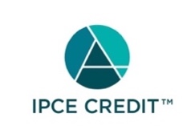

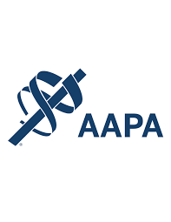




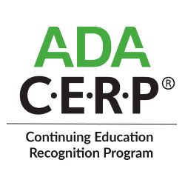

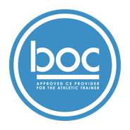

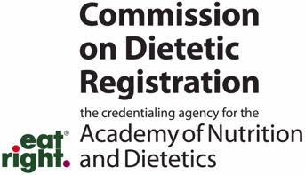
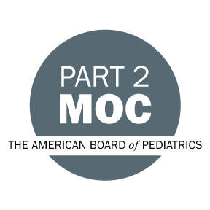

Disclosure of Relevant Financial Relationships and Content Validity

It is policy at Nationwide Children’s Hospital Office of Continuing Medical and Interprofessional Education for individuals who are in a position to control the content of an educational activity to disclose to the learners all relevant financial relationships that they have with any commercial interest that provide products or services that may be relevant to the content of this continuing education activity.

The intent of this policy is to ensure that Nationwide Children’s Hospital CME/CE certified activities promote quality and safety, are effective in improving medical practice, are based on valid content, and are independent of control from ineligible companies (those whose primary business is producing, marketing, selling, re-selling, or distributing healthcare products used by or on patients) and free of commercial bias. Mitigation methods including peer review of all content was conducted for all faculty presentations whose disclosure information was found to contain relationships that created a conflict of interest relevant to the topic of their presentation.

In addition, all faculty were instructed to provide balanced, scientifically rigorous and evidence-based presentations. All recommendations for patient care in accredited continuing education must be based on current science, evidence, and clinical reasoning, while giving a fair and balanced view of diagnostic and therapeutic options. All scientific research referred to, reported, or used in accredited education in support or justification of a patient care recommendation must conform to the generally accepted standards of experimental design, data collection, analysis, and interpretation.

IPCE Program DOCUMENT Vers. 2; 1.6.2022

