Activity Name:
- Urgent Care Network Bite Size Learning- Online

Date & Time:
- May 23, 2024 - 8:00 AM

Presentation Title:
- Urgent Care Bite Size Learning: Child Life

Speakers & Planners Information:

Name of individual | Individual's role in activity | Nature of Relationship(s) / Name of Ineligible Company(s)
Luciana Berg, MD | Other Planning Committee Member | Nothing to disclose - 04/22/2024
Sheila Giles, BSN, CPN | Faculty | Nothing to disclose - 08/04/2023
Jason Kovalcik, MD | Faculty | Nothing to disclose - 08/29/2023
Brittany Rogers , M.Ed. , CCLS | Faculty | Nothing to disclose - 02/20/2024
Margaret Redmond, MD | Faculty | Nothing to disclose - 04/12/2024
Michael Patrick, MD | Faculty | Nothing to disclose - 02/15/2024
Lindsay Brott, RN | Nurse Planner | Nothing to disclose - 04/03/2024
Jessica Hollar, RN | Faculty | Nothing to disclose - 07/17/2023
Jaclyn Huffman, RN, CPEN | Faculty | Nothing to disclose - 09/18/2023
Renee Owen, BSN | Other Planning Committee Member | Nothing to disclose - 01/05/2024

Session Objectives:

1 Understand the role of Certified Child Life Specialists
2 Outline clinical components of emotional safety
3 Discuss the clinical implications of emotional harm
4 Identify strategies to help children and families cope with medical procedures


In support of improving patient care, Nationwide Children’s hospital is jointly accredited by the American Nurses Credentialing Center (ANCC), the Accreditation Council for Pharmacy Education (ACPE), and the Accreditation Council for Continuing Medical Education (ACCME) to provide continuing medical education for the healthcare team. (1.00 ANCC contact hour(s))

(1.00 AMA PRA Category 1 CME Credit(s)™)

The Nationwide Children's Hospital designates this enduring material for a maximum of 1.00 AMA PRA Category 1 Credit(s)TM. Physicians should claim only the credit commensurate with the extent of their participation in the activity.

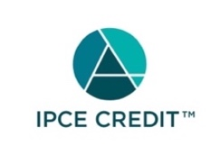






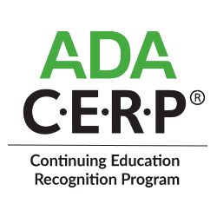

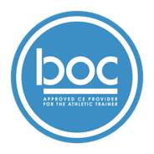

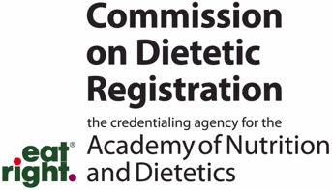
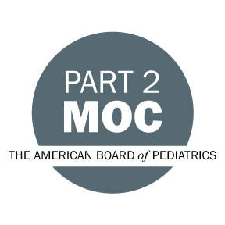

Disclosure of Relevant Financial Relationships and Content Validity

It is policy at Nationwide Children’s Hospital Office of Continuing Medical and Interprofessional Education for individuals who are in a position to control the content of an educational activity to disclose to the learners all relevant financial relationships that they have with any commercial interest that provide products or services that may be relevant to the content of this continuing education activity.

The intent of this policy is to ensure that Nationwide Children’s Hospital CME/CE certified activities promote quality and safety, are effective in improving medical practice, are based on valid content, and are independent of control from ineligible companies (those whose primary business is producing, marketing, selling, re-selling, or distributing healthcare products used by or on patients) and free of commercial bias. Mitigation methods including peer review of all content was conducted for all faculty presentations whose disclosure information was found to contain relationships that created a conflict of interest relevant to the topic of their presentation.

In addition, all faculty were instructed to provide balanced, scientifically rigorous and evidence-based presentations. All recommendations for patient care in accredited continuing education must be based on current science, evidence, and clinical reasoning, while giving a fair and balanced view of diagnostic and therapeutic options. All scientific research referred to, reported, or used in accredited education in support or justification of a patient care recommendation must conform to the generally accepted standards of experimental design, data collection, analysis, and interpretation.

IPCE Program DOCUMENT Vers. 2; 1.6.2022

