Activity Name:
- Diabetes Management Education

Date & Time:
- October 2, 2024 - 1:00 PM

Presentation Title:
- Diabetes Management Education 10/2/24

Speakers & Planners Information:

Name of individual | Individual's role in activity | Nature of Relationship(s) / Name of Ineligible Company(s)
Anita Peoples, BSN | Course Director, Faculty | Nothing to disclose - 12/22/2023
Elizabeth A Miehl, RD LD, Registered Dietitian | Faculty
Sarah Carvaines, RD, MPH | Course Director, Faculty | Nothing to disclose - 01/05/2024

ANCC Learning Outcomes:

1 Describe the pathophysiological differences between type 1 and type 2 diabetes
2 Define what target range means in diabetes
3 Identify the appropriate use of blood glucose meters and continuous glucose monitors in testing glucose values
4 Define basal-bolus insulin therapy
5 Utilize insulin-to-carb (ICR) to accurately calculate insulin bolus for food
6 Utilize correction factor (CF) to accurately calculate glucose correction doses.
7 Identify appropriate use of insulin pens and insulin pumps.
8 Identify causes, signs, and symptoms of hypoglycemia. Describe prevention and treatment, including use of glucagon.
9 Identify causes, signs, and symptoms of hyperglycemia. Describe prevention and treatment, including ketone management.
10 Identify causes, signs, and symptoms of DKA. Describe the need for emergency treatment.
11 Describe how to contact Nationwide Children's for guidance.

In support of improving patient care, Nationwide Children’s hospital is jointly accredited by the American Nurses Credentialing Center (ANCC), the Accreditation Council for Pharmacy Education (ACPE), and the Accreditation Council for Continuing Medical Education (ACCME) to provide continuing medical education for the healthcare team. (2.75 ANCC contact hour(s))

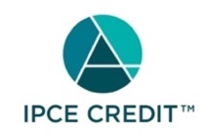

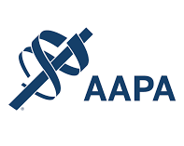

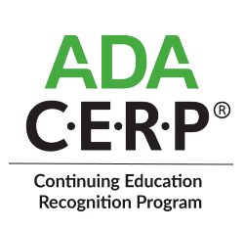

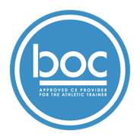

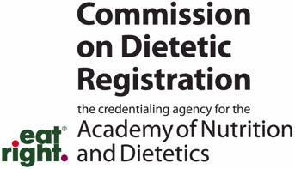
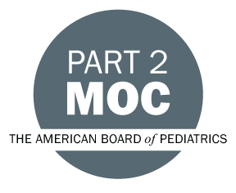

Disclosure of Relevant Financial Relationships and Content Validity

It is policy at Nationwide Children’s Hospital Office of Continuing Medical and Interprofessional Education for individuals who are in a position to control the content of an educational activity to disclose to the learners all relevant financial relationships that they have with any commercial interest that provide products or services that may be relevant to the content of this continuing education activity.

The intent of this policy is to ensure that Nationwide Children’s Hospital CME/CE certified activities promote quality and safety, are effective in improving medical practice, are based on valid content, and are independent of control from ineligible companies (those whose primary business is producing, marketing, selling, re-selling, or distributing healthcare products used by or on patients) and free of commercial bias. Mitigation methods including peer review of all content was conducted for all faculty presentations whose disclosure information was found to contain relationships that created a conflict of interest relevant to the topic of their presentation.

In addition, all faculty were instructed to provide balanced, scientifically rigorous and evidence-based presentations. All recommendations for patient care in accredited continuing education must be based on current science, evidence, and clinical reasoning, while giving a fair and balanced view of diagnostic and therapeutic options. All scientific research referred to, reported, or used in accredited education in support or justification of a patient care recommendation must conform to the generally accepted standards of experimental design, data collection, analysis, and interpretation.

IPCE Program DOCUMENT Vers. 2; 1.6.2022

