Activity Name:
- Self-Paced Course: 14th Annual Bodies in Motion Conference: Evaluation and Treatment Considerations for the Adolescent Athlete

Date & Time:
- July 1, 2024 - 8:00 AM

Speakers & Planners Information:

Name of individual | Individual's role in activity | Nature of Relationship(s) / Name of Ineligible Company(s)
Brittany Ibinson, PT, DPT, SCS | Other Planning Committee Member | Nothing to disclose - 11/16/2023
Shaun Coffman, PT, DPT, OCS | Other Planning Committee Member | Nothing to disclose - 11/06/2023
Christina Metzger, PT, DPT, OCS | Faculty | Nothing to disclose - 01/10/2024
Mitchell Selhorst, PhD, PT, DPT, OCS | Faculty | Nothing to disclose - 11/21/2023
Christopher Szulc, PT, DPT, OCS | Faculty | Nothing to disclose - 01/11/2024
Kathryn Iammarino, PT, DPT, MTC | Other Planning Committee Member | Nothing to disclose - 11/14/2023
Alexander Rospert, PT, DPT, OCS | Co-Director | Nothing to disclose - 01/11/2024
Tina Lepley, AT | Other Planning Committee Member | Nothing to disclose - 06/25/2024
Whitney Phillips | Activity Coordinator | Non-Clinical Exception
Jonathan Napolitano, MD, FAAPMR | Faculty | Royalties or Patent Beneficiary-Wolters Kluwer UpToDate - 03/06/2024
Amy E Valasek, MD | Faculty | Nothing to disclose - 01/11/2024
Jessica Jones, PT, DPT, CMPT | Faculty | Nothing to disclose - 01/12/2024
Jessica Hock, PT, DPT | Faculty | Nothing to disclose - 02/11/2024
Meghan Wiehe, PT, DPT, OCS | Co-Director | Nothing to disclose - 11/16/2023
Daniel Karam, PT, DPT, SCS | Faculty | Nothing to disclose - 01/10/2024
Madison Arnold, PT, DPT | Faculty | Nothing to disclose - 01/10/2024
Katie Lullo, PT, DPT, SCS | Faculty | Nothing to disclose - 06/04/2024
Madison Mize, PT, DPT | Faculty | Nothing to disclose - 02/07/2024
Quinton Kane, PT, DPT | Faculty | Nothing to disclose - 02/07/2024
Benjamin Lee, PT, DPT | Faculty | Nothing to disclose - 01/20/2024
Elizabeth Fraas, PT, DPT | Faculty | Nothing to disclose - 11/07/2023
Jeffrey Wergin, PT, DPT | Faculty | Nothing to disclose - 11/07/2023

Session Objectives:

1 Describe the evidence based return to sport considerations and testing pertaining to athletes following ACL reconstruction.
2 Summarize evidence based return to sport decision making processes for adolescent athletes
3 Identify the role of imaging in the rehab plan of care for adolescent athletes
4 Define the unique considerations of treating growth plate injuries in adolescents.
5 Identify signs of clinician burnout and at least 3 management strategies
6 Explain testing and interventions for adolescent athletes diagnosed with concussions.
7 Perform testing and interventions for adolescent athletes diagnosed with concussion
8 Interpret the video motion analysis of adolescent throwers and runners.


In support of improving patient care, Nationwide Children’s hospital is jointly accredited by the American Nurses Credentialing Center (ANCC), the Accreditation Council for Pharmacy Education (ACPE), and the Accreditation Council for Continuing Medical Education (ACCME) to provide continuing medical education for the healthcare team.



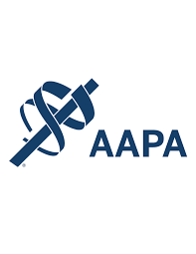




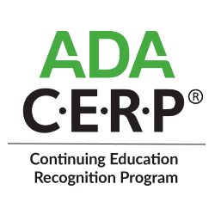

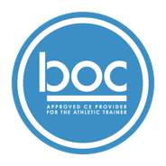

Nationwide Children’s Hospital (BOC AP#: P3772) is approved by the Board of Certification, Inc. to provide continuing education to Athletic Trainers (ATs). This program is eligible for a maximum of 7.50 Category A hours/CEUs. ATs should claim only those hours actually spent in the educational program.


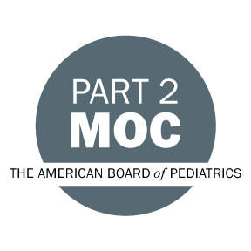

Disclosure of Relevant Financial Relationships and Content Validity

It is policy at Nationwide Children’s Hospital Office of Continuing Medical and Interprofessional Education for individuals who are in a position to control the content of an educational activity to disclose to the learners all relevant financial relationships that they have with any commercial interest that provide products or services that may be relevant to the content of this continuing education activity.

The intent of this policy is to ensure that Nationwide Children’s Hospital CME/CE certified activities promote quality and safety, are effective in improving medical practice, are based on valid content, and are independent of control from ineligible companies (those whose primary business is producing, marketing, selling, re-selling, or distributing healthcare products used by or on patients) and free of commercial bias. Mitigation methods including peer review of all content was conducted for all faculty presentations whose disclosure information was found to contain relationships that created a conflict of interest relevant to the topic of their presentation.

In addition, all faculty were instructed to provide balanced, scientifically rigorous and evidence-based presentations. All recommendations for patient care in accredited continuing education must be based on current science, evidence, and clinical reasoning, while giving a fair and balanced view of diagnostic and therapeutic options. All scientific research referred to, reported, or used in accredited education in support or justification of a patient care recommendation must conform to the generally accepted standards of experimental design, data collection, analysis, and interpretation.

IPCE Program DOCUMENT Vers. 2; 1.6.2022

