Activity Name:
- 3rd Annual Pediatric Dermatology Symposium

Date & Time:
- October 18, 2024 - 8:30 AM

Speakers & Planners Information:

Name of individual | Individual's role in activity | Nature of Relationship(s) / Name of Ineligible Company(s)
Andrea E Bonny, MD | Faculty | Nothing to disclose - 01/15/2024
Katya Harfmann, MD | Faculty | Nothing to disclose - 01/25/2024
Joy Mosser-Goldfarb, MD | Faculty | Nothing to disclose - 01/21/2024
Patricia Witman, MD | Faculty | Nothing to disclose - 01/30/2024
Kelly Dempsey, RN | Nurse Planner | Nothing to disclose - 01/10/2024
Esteban Fernandez Faith, MD | Co-Director | Nothing to disclose - 01/11/2024
Brittany Kozy, APRN, CPNP-PC | Course Director | Nothing to disclose - 01/12/2024
Sara Williard, RN | Nurse Planner | Nothing to disclose - 01/31/2024
Mahwish Irfan, MD | Faculty | Nothing to disclose - 01/12/2024
Michelle Kolada, RN, DN-C | Nurse Planner | Nothing to disclose - 01/31/2024
Cheyenne Story, MSN | Nurse Planner | Nothing to disclose - 01/09/2024

Session Objectives:

1 Identify common pediatric dermatologic conditions
2 Describe skin manifestations of chronic disease
3 Integrate updated treatment recommendations for pediatric dermatologic conditions
4 Improve patient outcomes through interprofessional communication and care.

In support of improving patient care, Nationwide Children’s hospital is jointly accredited by the American Nurses Credentialing Center (ANCC), the Accreditation Council for Pharmacy Education (ACPE), and the Accreditation Council for Continuing Medical Education (ACCME) to provide continuing medical education for the healthcare team. (6.50 ANCC contact hour(s))

(6.50 AMA PRA Category 1 CME Credit(s)™)

The Nationwide Children's Hospital designates this live activity for a maximum of 6.50 AMA PRA Category 1 Credit(s)TM. Physicians should claim only the credit commensurate with the extent of their participation in the activity.

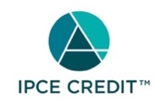

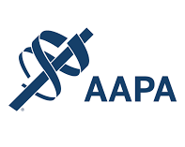

Nationwide Children's Hospital has been authorized by the American Academy of PAs (AAPA) to award AAPA Category 1 CME credit for activities planned in accordance with AAPA CME Criteria. This activity is designated for 6.50 AAPA Category 1 CME credit(s). Approval is valid for 2 years from the date of the activity. PAs should only claim credit commensurate with the extent of their participation.

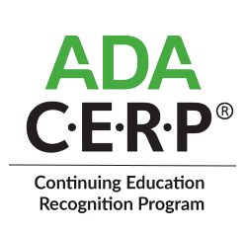

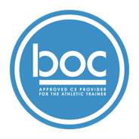

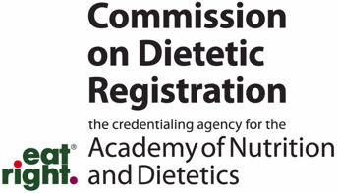
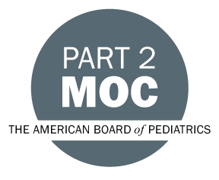

Disclosure of Relevant Financial Relationships and Content Validity

It is policy at Nationwide Children’s Hospital Office of Continuing Medical and Interprofessional Education for individuals who are in a position to control the content of an educational activity to disclose to the learners all relevant financial relationships that they have with any commercial interest that provide products or services that may be relevant to the content of this continuing education activity.

The intent of this policy is to ensure that Nationwide Children’s Hospital CME/CE certified activities promote quality and safety, are effective in improving medical practice, are based on valid content, and are independent of control from ineligible companies (those whose primary business is producing, marketing, selling, re-selling, or distributing healthcare products used by or on patients) and free of commercial bias. Mitigation methods including peer review of all content was conducted for all faculty presentations whose disclosure information was found to contain relationships that created a conflict of interest relevant to the topic of their presentation.

In addition, all faculty were instructed to provide balanced, scientifically rigorous and evidence-based presentations. All recommendations for patient care in accredited continuing education must be based on current science, evidence, and clinical reasoning, while giving a fair and balanced view of diagnostic and therapeutic options. All scientific research referred to, reported, or used in accredited education in support or justification of a patient care recommendation must conform to the generally accepted standards of experimental design, data collection, analysis, and interpretation.

IPCE Program DOCUMENT Vers. 2; 1.6.2022

