Activity Name:
- 2024 PENTA Conference

Date & Time:
- August 9, 2024 - 11:30 AM

Speakers & Planners Information:

Name of individual | Individual's role in activity | Nature of Relationship(s) / Name of Ineligible Company(s)
Karah Harvey-Nuckles, MD, MPH | Faculty | Nothing to disclose - 07/25/2024
Sarah Jones, BS, C-TAGME | Activity Coordinator | Non-Clinical Exception
Whitney Phillips | Other Planning Committee Member | Nothing to disclose - 01/09/2024
Katelyn Krivchenia, MD | Faculty | Nothing to disclose - 01/16/2024
Stacy P Ardoin, MD | Course Director, Faculty | Nothing to disclose - 06/19/2024
Bethanne B Thomas, CPNP, Pediatric NP | Nurse Planner | Nothing to disclose - 12/22/2023
Katie Moran, BS, CHES | Other Planning Committee Member | Nothing to disclose - 01/29/2024
Samantha Coss, MD, PhD, Pediatric Rheumatology Fellow | Faculty | Nothing to disclose - 07/26/2024
Erin R Garrick, BS | Other Planning Committee Member | Nothing to disclose - 05/01/2024
Christine Bearer, MD | Faculty | Nothing to disclose - 07/26/2024
Ian Rossman, MD, PhD | Faculty | Nothing to disclose - 07/18/2024
Lindsay Fannin, MD | Faculty | Nothing to disclose - 06/19/2024

Session Objectives:

1 Assess strategies used to accurately diagnose pediatric conditions seen in various rheumatic diseases.
2 Acquire new insights into clinical reasoning behind each diagnosis and the purpose of any needed intervention.
3 Acquire new knowledge in screening and management guidelines for multisystemic complications of rheumatic diseases.
4 Improve patient outcomes by collaboration with other specialties for research and quality improvement activities.

ANCC Learning Outcomes:

1 Review characteristics of localized scleroderma (morphea)
2 Understand potential extra-cutaneous disease manifestations of localized scleroderma and modalities used to screen for these
3 Review current management and therapies used to treat localized scleroderma
4 Review a model of existing telehealth program (Stanford Children's as a model)
5 Review current use cases of telehealth in pediatric subspecialty care within inpatient, ambulatory, and research settings
6 Understand diversity, equity, and inclusion implications with telehealth
7 Review gaps and opportunities in telehealth
8 Review of mind-body strategies for pediatric chronic pain management
9 Learn about a brief intervention program - The Comfort Ability Program (CAP) - targeting mind-body skill development for teens and their families with chronic pain
10 Understand how to be an effective conduit for pediatric chronic pain mind-body resources including: how to describe mid-body skills to families and why they work and effective collaboration tips with psychosocial supports (psychology, school)
11 Review the characteristic pathologic findings of Chronic Recurrent Multifocal Osteomyelitis (CRMO)
12 Understand the pathologic nuances of osteitis type disease of childhood
13 Review examples of dermatopathology associated with cases of chronic osteitis
14 Review the differential diagnosis for acute encephalitis
15 Review the work up for acute encephalitis
16 Discuss the treatment for a rare presentation of encephalitis

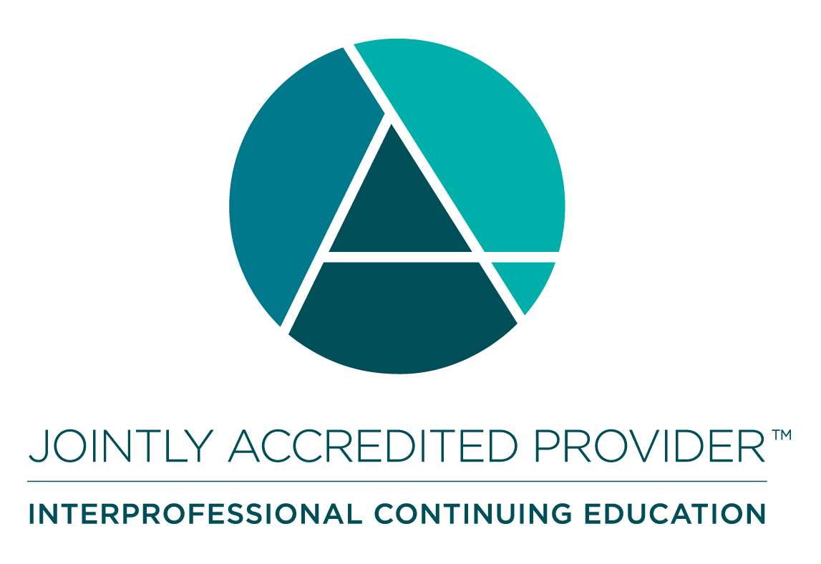
In support of improving patient care, Nationwide Children’s hospital is jointly accredited by the American Nurses Credentialing Center (ANCC), the Accreditation Council for Pharmacy Education (ACPE), and the Accreditation Council for Continuing Medical Education (ACCME) to provide continuing medical education for the healthcare team. (3.00 ANCC contact hour(s))

(3.00 AMA PRA Category 1 CME Credit(s)™)

The Nationwide Children's Hospital designates this live activity for a maximum of 3.00 AMA PRA Category 1 Credit(s)TM. Physicians should claim only the credit commensurate with the extent of their participation in the activity.

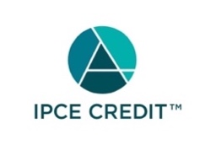

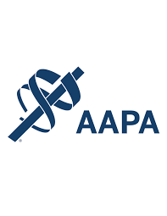




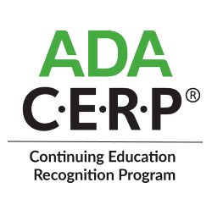

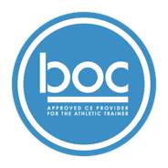


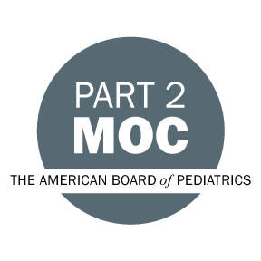

Disclosure of Relevant Financial Relationships and Content Validity

It is policy at Nationwide Children’s Hospital Office of Continuing Medical and Interprofessional Education for individuals who are in a position to control the content of an educational activity to disclose to the learners all relevant financial relationships that they have with any commercial interest that provide products or services that may be relevant to the content of this continuing education activity.

The intent of this policy is to ensure that Nationwide Children’s Hospital CME/CE certified activities promote quality and safety, are effective in improving medical practice, are based on valid content, and are independent of control from ineligible companies (those whose primary business is producing, marketing, selling, re-selling, or distributing healthcare products used by or on patients) and free of commercial bias. Mitigation methods including peer review of all content was conducted for all faculty presentations whose disclosure information was found to contain relationships that created a conflict of interest relevant to the topic of their presentation.

In addition, all faculty were instructed to provide balanced, scientifically rigorous and evidence-based presentations. All recommendations for patient care in accredited continuing education must be based on current science, evidence, and clinical reasoning, while giving a fair and balanced view of diagnostic and therapeutic options. All scientific research referred to, reported, or used in accredited education in support or justification of a patient care recommendation must conform to the generally accepted standards of experimental design, data collection, analysis, and interpretation.

IPCE Program DOCUMENT Vers. 2; 1.6.2022

