Activity Name:
- Rare Disease Day 2024

Date & Time:
- March 1, 2024 - 3:00 PM

Speakers & Planners Information:

Name of individual | Individual's role in activity | Nature of Relationship(s) / Name of Ineligible Company(s)

In support of improving patient care, Nationwide Children’s hospital is jointly accredited by the American Nurses Credentialing Center (ANCC), the Accreditation Council for Pharmacy Education (ACPE), and the Accreditation Council for Continuing Medical Education (ACCME) to provide continuing medical education for the healthcare team.

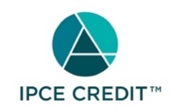

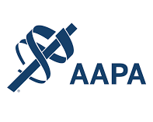

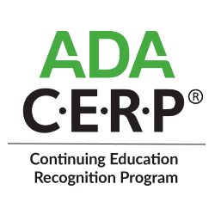

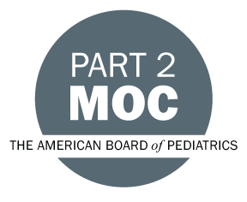

Disclosure of Relevant Financial Relationships and Content Validity

It is policy at Nationwide Children’s Hospital Office of Continuing Medical and Interprofessional Education for individuals who are in a position to control the content of an educational activity to disclose to the learners all relevant financial relationships that they have with any commercial interest that provide products or services that may be relevant to the content of this continuing education activity.

The intent of this policy is to ensure that Nationwide Children’s Hospital CME/CE certified activities promote quality and safety, are effective in improving medical practice, are based on valid content, and are independent of control from ineligible companies (those whose primary business is producing, marketing, selling, re-selling, or distributing healthcare products used by or on patients) and free of commercial bias. Mitigation methods including peer review of all content was conducted for all faculty presentations whose disclosure information was found to contain relationships that created a conflict of interest relevant to the topic of their presentation.

In addition, all faculty were instructed to provide balanced, scientifically rigorous and evidence-based presentations. All recommendations for patient care in accredited continuing education must be based on current science, evidence, and clinical reasoning, while giving a fair and balanced view of diagnostic and therapeutic options. All scientific research referred to, reported, or used in accredited education in support or justification of a patient care recommendation must conform to the generally accepted standards of experimental design, data collection, analysis, and interpretation.

IPCE Program DOCUMENT Vers. 2; 1.6.2022

