Activity Name:
- Adult Learning Concepts: How to be the Best Preceptor You Can Be

Date & Time:
- November 16, 2023 - 12:00 PM

Presentation Title:
- Adult Learning Concepts: How to be the Best Preceptor You Can Be 11/16/23

Speakers & Planners Information:

Name of individual | Individual's role in activity | Name of Ineligible Company(s) / Nature of Relationship(s) | Professional Title
Courtney Bishop, PA-C | Other Planning Committee Member | Non-Clinical Exception | Physician Assistant
Allison Z Kelly, DNP | Activity Coordinator, Faculty | Non-Clinical Exception

Session Objectives:

1 Identify common characteristics associated with different learning styles
2 Implement strategies for supporting the struggling learner

ANCC Learning Outcomes:

1 The participant should be able to discuss the multiple roles performed by a preceptor and apply these in the clinical setting.
2 Identify and utilize the resources available to support successful precepting a new or transitioning APRN

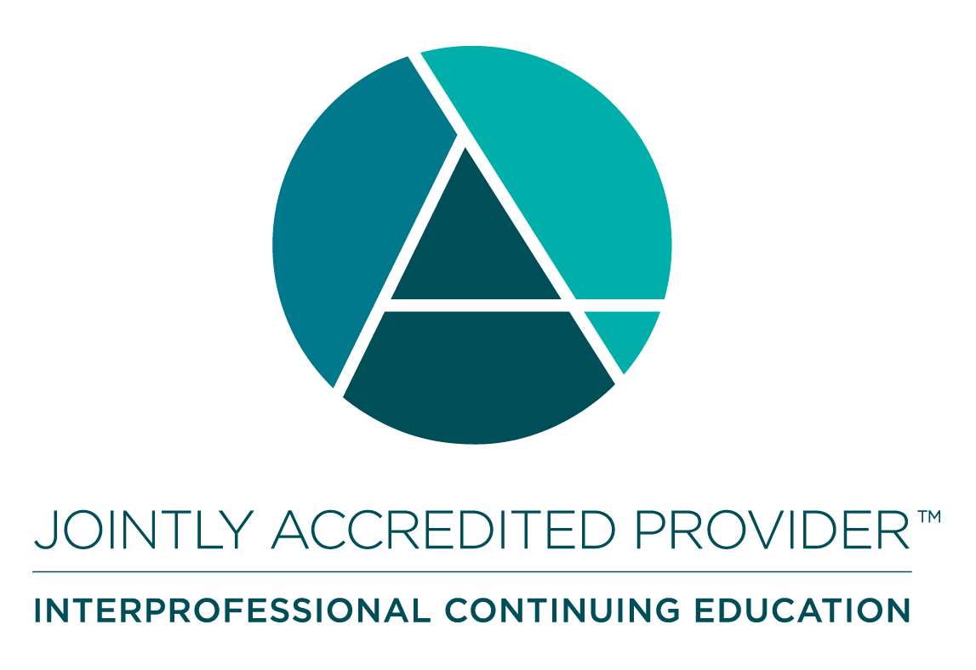
In support of improving patient care, Nationwide Children’s hospital is jointly accredited by the American Nurses Credentialing Center (ANCC), the Accreditation Council for Pharmacy Education (ACPE), and the Accreditation Council for Continuing Medical Education (ACCME) to provide continuing medical education for the healthcare team. (1.00 ANCC contact hour(s))

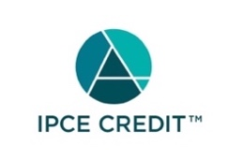

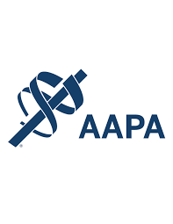

Nationwide Children's Hospital has been authorized by the American Academy of PAs (AAPA) to award AAPA Category 1 CME credit for activities planned in accordance with AAPA CME Criteria. This activity is designated for 1.00 AAPA Category 1 CME credit(s). Approval is valid for 2 years from the date of the activity. PAs should only claim credit commensurate with the extent of their participation.




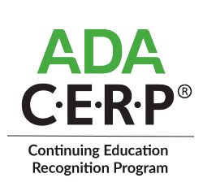

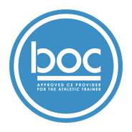

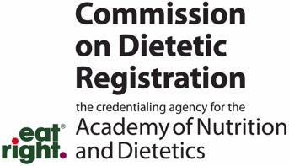
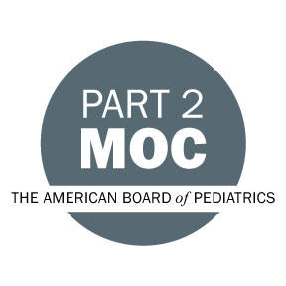

Disclosure of Relevant Financial Relationships and Content Validity

It is policy at Nationwide Children’s Hospital Office of Continuing Medical and Interprofessional Education for individuals who are in a position to control the content of an educational activity to disclose to the learners all relevant financial relationships that they have with any commercial interest that provide products or services that may be relevant to the content of this continuing education activity.

The intent of this policy is to ensure that Nationwide Children’s Hospital CME/CE certified activities promote quality and safety, are effective in improving medical practice, are based on valid content, and are independent of control from ineligible companies (those whose primary business is producing, marketing, selling, re-selling, or distributing healthcare products used by or on patients) and free of commercial bias. Mitigation methods including peer review of all content was conducted for all faculty presentations whose disclosure information was found to contain relationships that created a conflict of interest relevant to the topic of their presentation.

In addition, all faculty were instructed to provide balanced, scientifically rigorous and evidence-based presentations. All recommendations for patient care in accredited continuing education must be based on current science, evidence, and clinical reasoning, while giving a fair and balanced view of diagnostic and therapeutic options. All scientific research referred to, reported, or used in accredited education in support or justification of a patient care recommendation must conform to the generally accepted standards of experimental design, data collection, analysis, and interpretation.

IPCE Program DOCUMENT Vers. 2; 1.6.2022

