Activity Name:
- 2023 NCH Pediatric Sports Medicine & Orthopedics Conference

Date & Time:
- November 10, 2023 - 8:00 AM

Speakers & Planners Information:

Name of individual | Individual's role in activity | Nature of Relationship(s) / Name of Ineligible Company(s)
Thomas L Pommering, DO, FAAFP, FAMSSM | Faculty | Nothing to disclose - 08/10/2023
Kyla Driest, MD, MEd | Faculty | Nothing to disclose - 10/30/2023
Steven Cuff, MD | Course Director | Nothing to disclose - 10/20/2023
Kathryn S Milks, MD | Faculty | Nothing to disclose - 10/02/2023
RYAN INGLEY, AT, ATC | Faculty | Nothing to disclose - 09/13/2023
Reno Ravindran, MD, Sports Medicine | Faculty | Nothing to disclose - 10/09/2023
Margaret Rule, MS, AT, ATC | Other Planning Committee Member | Nothing to disclose - 04/27/2023
Lindsey Vater, PsyD | Faculty | Paid consultant-Spalding University (Relationship has ended)|Paid consultant-Tourette Association of America (Relationship has ended) - 10/05/2023
Jonathan Napolitano, MD, FAAPMR | Faculty | Royalties or Patent Beneficiary-Wolters Kluwer UpTodDate - 08/20/2023
Craig Smith, MD | Faculty | Nothing to disclose - 10/11/2023
Lia Mazzarelli, BS, C-TAGME | Other Planning Committee Member | Nothing to disclose - 04/27/2023
Edward J Oberle, MD | Faculty | Nothing to disclose - 06/30/2023
Richard E. Rodenberg, MD | Faculty | Royalties or Patent Beneficiary-Wolter Kluwer--UpToDate - 08/18/2023
Drew H Duerson, MD, RMSK | Faculty, Other Planning Committee Member | Nothing to disclose - 04/17/2023
James P MacDonald, MD, MPH, FAAFP, FACSM, FAMSSM, FSEM_IRE | Faculty | Nothing to disclose - 06/12/2023
Kathleen Shiplett, PT | Faculty | Nothing to disclose - 06/16/2023
Amanda Vokoun, PT, DPT | Faculty | Nothing to disclose - 10/27/2023
Meghan Wiehe, PT, DPT, OCS | Other Planning Committee Member | Nothing to disclose - 04/27/2023
Daniel Karam, PT, DPT, SCS | Faculty | Nothing to disclose - 04/21/2023
Jesse Padgett, MS, CSCS, RSCC, SCCC | Faculty | Nothing to disclose - 07/28/2023
John D Smith, MBA, MSEd, AT, ATC | Faculty | Nothing to disclose - 09/13/2023
Katie Lullo, PT, DPT, SCS | Faculty | Nothing to disclose - 10/09/2023
Sakiko Minagawa, MS, RD, CSSD, LD | Faculty | Nothing to disclose - 01/18/2023
Erin R Garrick, BS | Other Planning Committee Member | Nothing to disclose - 01/11/2023
Tracy Sferra, MS | Activity Coordinator | Nothing to disclose - 10/05/2023
Justin Leasure, MD | Faculty | Nothing to disclose - 10/25/2023
Alex Dibartola, MD, MPH | Faculty | Nothing to disclose - 10/10/2023

Session Objectives:

1 Outline the standard treatment interventions for an athlete that has sustained a concussion
2 Identify appropriate strength training interventions for the adolescent athlete
3 Explain practical applications that can be used in the rehabilitation setting to manage the behaviorally challenging athlete
4 Reduce the risk of complications associated with pediatric fractures
5 Understand the presentation and treatment of various causes of exertional leg pain
6 Recognize the causes of a swollen joint that are not related to injury
7 Assess the epidemiology, diagnosis and management of breathing problems in athletes

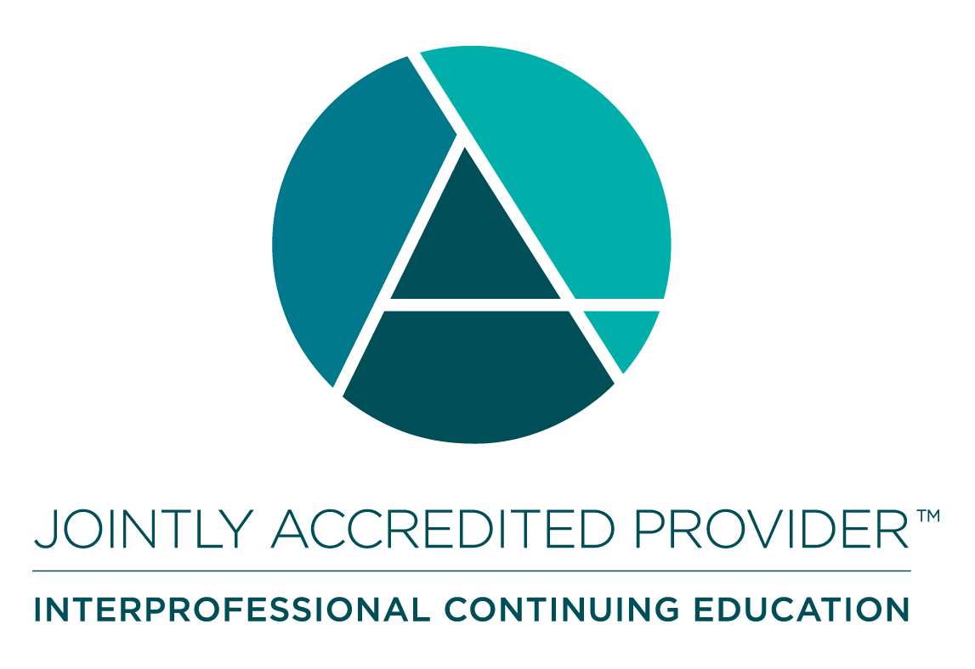
In support of improving patient care, Nationwide Children’s hospital is jointly accredited by the American Nurses Credentialing Center (ANCC), the Accreditation Council for Pharmacy Education (ACPE), and the Accreditation Council for Continuing Medical Education (ACCME) to provide continuing medical education for the healthcare team. (7.00 ANCC contact hour(s))

(7.00 AMA PRA Category 1 CME Credit(s)™)

The Nationwide Children's Hospital designates this live activity for a maximum of 7.00 AMA PRA Category 1 Credit(s)TM. Physicians should claim only the credit commensurate with the extent of their participation in the activity.

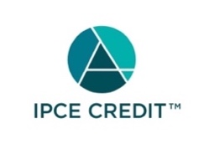

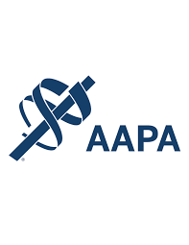

Nationwide Children's Hospital has been authorized by the American Academy of PAs (AAPA) to award AAPA Category 1 CME credit for activities planned in accordance with AAPA CME Criteria. This activity is designated for 7.00 AAPA Category 1 CME credit(s). Approval is valid for 2 years from the date of the activity. PAs should only claim credit commensurate with the extent of their participation.

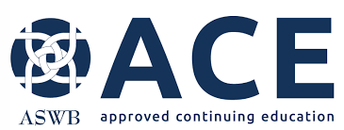


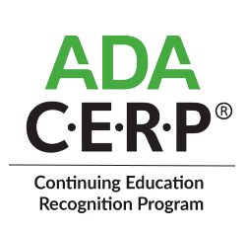

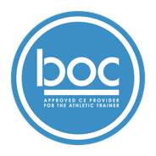

Nationwide Children’s Hospital (BOC AP#: P3772) is approved by the Board of Certification, Inc. to provide continuing education to Athletic Trainers (ATs). This program is eligible for a maximum of 7.00 Category A hours/CEUs. ATs should claim only those hours actually spent in the educational program.


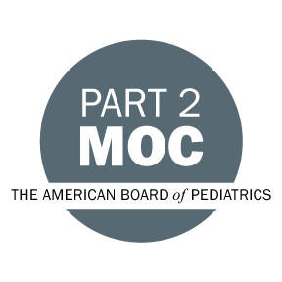

Disclosure of Relevant Financial Relationships and Content Validity

It is policy at Nationwide Children’s Hospital Office of Continuing Medical and Interprofessional Education for individuals who are in a position to control the content of an educational activity to disclose to the learners all relevant financial relationships that they have with any commercial interest that provide products or services that may be relevant to the content of this continuing education activity.

The intent of this policy is to ensure that Nationwide Children’s Hospital CME/CE certified activities promote quality and safety, are effective in improving medical practice, are based on valid content, and are independent of control from ineligible companies (those whose primary business is producing, marketing, selling, re-selling, or distributing healthcare products used by or on patients) and free of commercial bias. Mitigation methods including peer review of all content was conducted for all faculty presentations whose disclosure information was found to contain relationships that created a conflict of interest relevant to the topic of their presentation.

In addition, all faculty were instructed to provide balanced, scientifically rigorous and evidence-based presentations. All recommendations for patient care in accredited continuing education must be based on current science, evidence, and clinical reasoning, while giving a fair and balanced view of diagnostic and therapeutic options. All scientific research referred to, reported, or used in accredited education in support or justification of a patient care recommendation must conform to the generally accepted standards of experimental design, data collection, analysis, and interpretation.

IPCE Program DOCUMENT Vers. 2; 1.6.2022

