Activity Name:
- Addressing Racism in Maternal-Infant Care - Setting the Baseline

Date & Time:
- March 14, 2023 - 12:00 PM

Presentation Title:
- Obstetric Racism - Its Etiology and Impact on Black Maternal, Infant and Family Health Session One

Speakers & Planners Information:

Name of individual | Individual's role in activity | Nature of Relationship(s) / Name of Ineligible Company(s)
Venita Robinson, MHSA | Activity Administrator | Nothing to disclose - 09/02/2022
Ashley Banks, Research Associate | Faculty
Valencia Walker, MD | Other Planning Committee Member | Nothing to disclose - 08/15/2022
Dysha Cole, MSW, LSW | Other Planning Committee Member | Nothing to disclose - 03/17/2022
Kierra Barnett, PhD | Faculty | Nothing to disclose - 08/10/2022
Deja Dunning, MHA | Activity Coordinator | Nothing to disclose - 06/27/2022
Kamilah Dixon, MD | Faculty | Nothing to disclose - 07/13/2022
Amber Bondurant, MD | Faculty | Nothing to disclose - 09/12/2022
Desiré Bennett | Faculty | Nothing to disclose - 08/18/2022
Dorian Wingard, MPH | Faculty | Nothing to disclose - 08/09/2022
Jessica Roach, MPH | Faculty | Nothing to disclose - 09/30/2022
Lynae Picou, BSN | Other Planning Committee Member | Nothing to disclose - 08/09/2022
Whitney Gordon, Other | Faculty

Session Objectives:

1 Develop an understanding of the created consequences of the unmet Social Determinants of Health throughout the 400+ year timeline
2 Establish the intra-connection between Black Family Health Inequity and Black Maternal and Infant Mortality
3 Address the inherent racism of systems, inclusive of health care, and how this impacts Black Family Health and Wellness


In support of improving patient care, Nationwide Children’s hospital is jointly accredited by the American Nurses Credentialing Center (ANCC), the Accreditation Council for Pharmacy Education (ACPE), and the Accreditation Council for Continuing Medical Education (ACCME) to provide continuing medical education for the healthcare team. (1.00 ANCC contact hour(s))

(1.00 AMA PRA Category 1 CME Credit(s)™)

The Nationwide Children's Hospital designates this internet point-of-care activity,live activity,other:in-person and live stream for a maximum of 1.00 AMA PRA Category 1 Credit(s)TM. Physicians should claim only the credit commensurate with the extent of their participation in the activity.



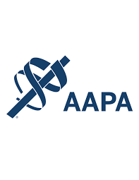

Nationwide Children's Hospital has been authorized by the American Academy of PAs (AAPA) to award AAPA Category 1 CME credit for activities planned in accordance with AAPA CME Criteria. This activity is designated for 1.00 AAPA Category 1 CME credit(s). Approval is valid for 2 years from the date of the activity. PAs should only claim credit commensurate with the extent of their participation.



As a Jointly Accredited Organization, Nationwide Children's Hospital is approved to offer social work continuing education by the Association of Social Work Boards (ASWB) Approved Continuing Education (ACE) program. Organizations, not individual courses, are approved under this program. State and provincial regulatory boards have the final authority to determine whether an individual course may be accepted for continuing education credit. Nationwide Children's Hospital maintains responsibility for this course. Social workers completing this course receive 1.00 continuing education credit(s).


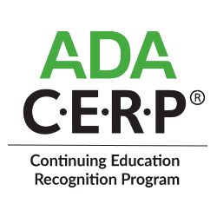

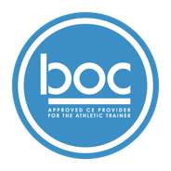

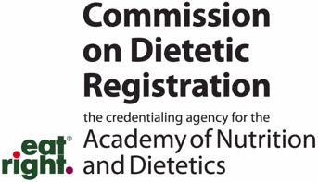
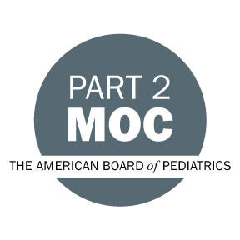

Disclosure of Relevant Financial Relationships and Content Validity

It is policy at Nationwide Children’s Hospital Office of Continuing Medical and Interprofessional Education for individuals who are in a position to control the content of an educational activity to disclose to the learners all relevant financial relationships that they have with any commercial interest that provide products or services that may be relevant to the content of this continuing education activity.

The intent of this policy is to ensure that Nationwide Children’s Hospital CME/CE certified activities promote quality and safety, are effective in improving medical practice, are based on valid content, and are independent of control from ineligible companies (those whose primary business is producing, marketing, selling, re-selling, or distributing healthcare products used by or on patients) and free of commercial bias. Mitigation methods including peer review of all content was conducted for all faculty presentations whose disclosure information was found to contain relationships that created a conflict of interest relevant to the topic of their presentation.

In addition, all faculty were instructed to provide balanced, scientifically rigorous and evidence-based presentations. All recommendations for patient care in accredited continuing education must be based on current science, evidence, and clinical reasoning, while giving a fair and balanced view of diagnostic and therapeutic options. All scientific research referred to, reported, or used in accredited education in support or justification of a patient care recommendation must conform to the generally accepted standards of experimental design, data collection, analysis, and interpretation.

IPCE Program DOCUMENT Vers. 2; 1.6.2022

