Activity Name:
- BH Education: An Introduction to Motivational Interviewing

Date & Time:
- February 1, 2022 - 9:30 AM

Speakers Information:

Allison Depoy, LISW-S
Kathleen T Roush, MSW, LISW-S

Planners Information:

Allison Depoy, LISW-S (Other Planning Committee Member)
Amy Hahn, Psychologist (Other Planning Committee Member)
Susan Orme, MSN (Nurse Planner)
Natalie Powell, LPCC-S (Other Planning Committee Member)
Kathleen Roush, MSW, LISW-S (Other Planning Committee Member)

Activity Objectives:
1 Define how Motivational Interviewing spirit benefits the collaborative relationship between helping professionals and clients/patients.
2 Translate how core MI skills can be used in varied areas of practice.
3 Practice utilizing spirit and skills in a controlled setting.
4 Increase practical ways of guiding patients/clients in making positive healthcare changes.

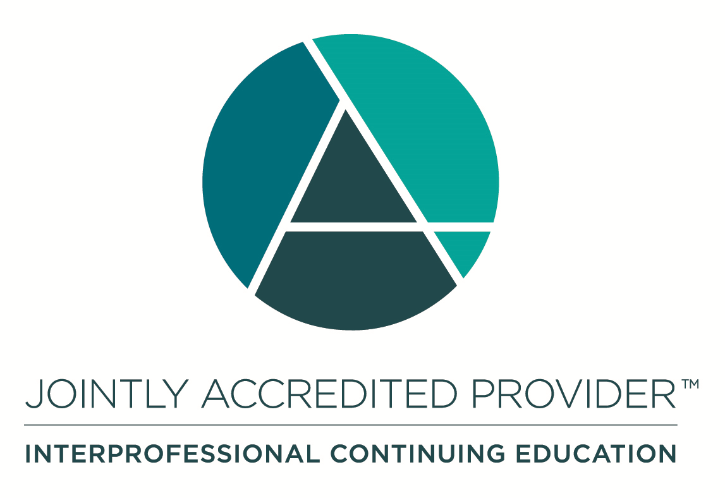
In support of improving patient care, Nationwide Children’s Hospital is jointly accredited by the American Nurses Credentialing Center (ANCC), the Accreditation Council for Pharmacy Education (ACPE), and the Accreditation Council for Continuing Medical Education (ACCME) to provide continuing medical education for the healthcare team. (3.0 ANCC contact hours; 3.0 CME hours)

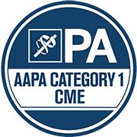

As a Jointly Accredited Organization, Nationwide Children's Hospital is approved to offer social work continuing education by the Association of Social Work Boards (ASWB) Approved Continuing Education (ACE) program. Organizations, not individual courses, are approved under this program. State and provincial regulatory boards have the final authority to determine whether an individual course may be accepted for continuing education credit. Nationwide Children's Hospital maintains responsibility for this course. Social workers completing this course receive 3.0 continuing education credits.

Disclosure of Relevant Financial Relationships and Unapproved Uses of Products

It is policy at Nationwide Children’s Hospital Office of Continuing Medical and Interprofessional Education for individuals who are in a position to control the content of an educational activity to disclose to the learners all relevant financial relationships that they have with any commercial interest that provide products or services that may be relevant to the content of this continuing education activity. For this purpose, we consider relationships of the person involved to include financial relationships of a spouse or partner.

The intent of this policy is to ensure that Nationwide Children’s Hospital CME/CE certified activities promote quality and safety, are effective in improving medical practice, are based on valid content, and are independent of control from commercial interests and free of commercial bias. Peer review of all content was conducted for all faculty presentations whose disclosure information was found to contain relationships that created a conflict of interest relevant to the topic of their presentation. In addition, all faculty were instructed to provide balanced, scientifically rigorous and evidence-based presentations.

IPCE Program DOCUMENT Vers. 1; 4.3.2020

