Activity Name:
- 2022 Neonatal/Perinatal Conference

Date & Time:
- May 17, 2022 - 7:30 AM

Speakers & Planners Information:

Name of individual | Individual's role in activity | Nature of Relationship(s) / Name of Ineligible Company(s)
Gail Bagwell , DNP, APRN, CNS | Co-Director | Nothing to disclose - 03/31/2022
Christina Phelps , MD | Faculty | Nothing to disclose - 05/12/2022
Amy Baughcum, PhD | Faculty | Nothing to disclose - 05/10/2022
Elizabeth A Rodgers, MSN, RNC-NIC | Faculty | Nothing to disclose - 03/29/2022
Jennifer Hofherr, MS, OTR/L, NIDCAP Trainer, CNT, NTMTC | Other Planning Committee Member | Nothing to disclose - 11/17/2021
Jacqueline Magers, Pharmacist | Other Planning Committee Member | Nothing to disclose - 02/07/2022
Christine A Willoughby, MSN, RN | Other Planning Committee Member | Nothing to disclose - 11/17/2021
Judith Hanlon, MS, RN | Other Planning Committee Member | Nothing to disclose - 11/17/2021
Jessica Niski, PT, DPT | Faculty | Nothing to disclose - 05/10/2022
Leeann Pavlek, MD | Other Planning Committee Member | Nothing to disclose - 11/21/2021
CARL BACKES, MD | Faculty | Nothing to disclose - 05/13/2022
Laura Marzec, IMG | Faculty | Nothing to disclose - 05/13/2022
Karen Diefenbach, MD | Faculty | Nothing to disclose - 05/13/2022
Lisa Holloway | Faculty | Nothing to disclose - 04/28/2022
Matt Kielt, MD | Faculty | Nothing to disclose - 05/12/2022
Shannon L Gillespie , PsyD | Faculty | Nothing to disclose - 02/28/2022
Cecilie Halling, MD | Faculty | Nothing to disclose - 05/11/2022
Bimal Chaudhari, MD MPH | Faculty | Honoraria-Connected Research (Relationship has ended) - 05/10/2022
Tahagod Mohamed, MD | Faculty | Nothing to disclose - 12/14/2021
Erin Keels, DNP, APRN CNP | Co-Director | Nothing to disclose - 09/21/2021
Mary Gossard, MSN, CNS | Other Planning Committee Member | Nothing to disclose - 05/16/2022
Jason Jackson, DO | Faculty | Nothing to disclose - 04/13/2022
Maged M Costantine, MD | Faculty | Consulting Fee-Obseva, Momenta, Progenity (Relationship has ended)|Grant or research support-Baxter, Amag - 12/21/2021
Colleen Miller, PharmD | Faculty | Nothing to disclose - 12/30/2021
Bianca Zapanta, DO | Faculty | Nothing to disclose - 01/05/2022
Leslie Coonfare, DNP | Nurse Planner | Non-Clinical Exception
Sara Conroy, PhD | Faculty | Nothing to disclose - 05/13/2022
Courtney Cooke, MA | Other Planning Committee Member | Non-Clinical Exception
Jonathan Klein, MD | Faculty | Nothing to disclose - 01/12/2022
Katlyn McGratten, PhD | Faculty | Nothing to disclose - 05/03/2022
Michael Narvey, MD, FRCPC, FAAP | Faculty | Advisor-Radiometer (Relationship has ended) - 12/21/2021
Kelli D Kelley | Faculty | Nothing to disclose - 05/12/2022
Sara Anderson | Faculty | Nothing to disclose - 02/01/2022
Annie Janvier, MD, PhD | Faculty | Nothing to disclose - 05/24/2021
Media Esser, PhD | Faculty | Nothing to disclose - 03/03/2022
Abby Brodbeck | Faculty | Nothing to disclose - 03/29/2022
Heidi Cohen, NP | Faculty | Nothing to disclose - 03/03/2022
Christina N Stine, MD, Medical Director of Doctors Hospital/Neonatologist | Faculty | Speakers Bureau-Abbott Nutrition (Relationship has ended) - 05/13/2022

Session Objectives:

1 Utilize the science and tools of quality improvement to improve patient outcomes.
2 Implement the latest, evidence-based treatment options in perinatal and neonatal patients to improve the quality of care.
3 Incorporate the most up to date, relevant patient education and self-management guidelines into practice so that patients and families can utilize before, during and after discharge in order to successfully transition care back into the home.

In support of improving patient care, Nationwide Children’s hospital is jointly accredited by the American Nurses Credentialing Center (ANCC), the Accreditation Council for Pharmacy Education (ACPE), and the Accreditation Council for Continuing Medical Education (ACCME) to provide continuing medical education for the healthcare team. (18.75 ANCC contact hour(s)) (18.75 ACPE contact hour(s))

(18.75 AMA PRA Category 1 CME Credit(s)™)

The Nationwide Children's Hospital designates this live activity for a maximum of 18.75 AMA PRA Category 1 Credit(s)TM. Physicians should claim only the credit commensurate with the extent of their participation in the activity.

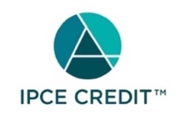

This activity was planned by and for the healthcare team, and learners will receive 18.75 Interprofessional Continuing Education (IPCE) credit(s) for learning and change.

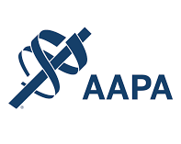

Nationwide Children's Hospital has been authorized by the American Academy of PAs (AAPA) to award AAPA Category 1 CME credit for activities planned in accordance with AAPA CME Criteria. This activity is designated for 18.75 AAPA Category 1 CME credit(s). Approval is valid for 2 years from the date of the activity. PAs should only claim credit commensurate with the extent of their participation.

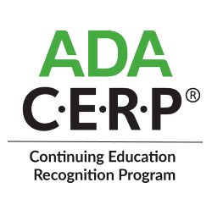

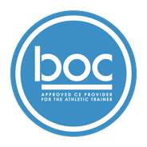

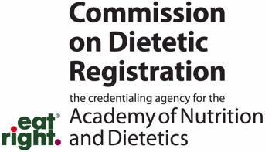
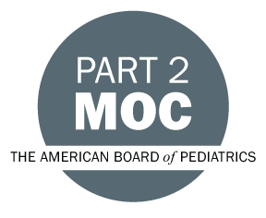

Disclosure of Relevant Financial Relationships and Content Validity

It is policy at Nationwide Children’s Hospital Office of Continuing Medical and Interprofessional Education for individuals who are in a position to control the content of an educational activity to disclose to the learners all relevant financial relationships that they have with any commercial interest that provide products or services that may be relevant to the content of this continuing education activity.

The intent of this policy is to ensure that Nationwide Children’s Hospital CME/CE certified activities promote quality and safety, are effective in improving medical practice, are based on valid content, and are independent of control from ineligible companies (those whose primary business is producing, marketing, selling, re-selling, or distributing healthcare products used by or on patients) and free of commercial bias. Mitigation methods including peer review of all content was conducted for all faculty presentations whose disclosure information was found to contain relationships that created a conflict of interest relevant to the topic of their presentation.

In addition, all faculty were instructed to provide balanced, scientifically rigorous and evidence-based presentations. All recommendations for patient care in accredited continuing education must be based on current science, evidence, and clinical reasoning, while giving a fair and balanced view of diagnostic and therapeutic options. All scientific research referred to, reported, or used in accredited education in support or justification of a patient care recommendation must conform to the generally accepted standards of experimental design, data collection, analysis, and interpretation.

IPCE Program DOCUMENT Vers. 2; 1.6.2022

