Activity Name:
- 2021 Psychiatry Grand Rounds On Demand: Advances in Youth Suicide Research and Prevention

Date & Time:
- September 29, 2021 - 3:00 PM

Speakers Information:

John P Ackerman , Coordinator Disclosure(s) - I/we have no financial relationships to report.

Jeff Bridge, PhD Disclosure(s) - Member of Scientific Advisory Board-Clarigent Health

Planners Information:

John Ackerman , Coordinator (Other Planning Committee Member) Disclosure(s) - I/we have no financial relationships to report.

David Axelson , MD (Other Planning Committee Member) Disclosure(s) - Royalty-Wolters Kluwer

Jeff Bridge, PhD (Other Planning Committee Member) Disclosure(s) - Member of Scientific Advisory Board-Clarigent Health

Sherry Fletcher, None (Other Planning Committee Member) Disclosure(s) - I/we have no financial relationships to report.

Mary Fristad, PhD (Other Planning Committee Member) Disclosure(s) - Royalty-American Psychiatric Publishing,Royalty-JK Seminars,Royalty-Guilford Press,Contracted Research-Janssen,Editor-Evidence-based Practice in Child and Adolescent Mental Health

Haley Johnson, B.S. (Other Planning Committee Member) Disclosure(s) - I/we have no financial relationships to report.

Anna Kerlek, MD (Other Planning Committee Member) Disclosure(s) - I/we have no financial relationships to report.

Gina McDowell, LPCC-S (Other Planning Committee Member) Disclosure(s) - I/we have no financial relationships to report.

Nancy Noyes, APRN (Other Planning Committee Member) Disclosure(s) - I/we have no financial relationships to report.

Susan Orme, MSN (Other Planning Committee Member) Disclosure(s) - I/we have no financial relationships to report.

Jennifer Reese, PsyD (Other Planning Committee Member) Disclosure(s) - I/we have no financial relationships to report.

Activity Objectives:
1 Understand trends in youth suicide focusing on recent CSPR research that highlights vulnerable populations.
2 Describe the rationale and benefits of suicide screening as well as universal suicide prevention approaches in schools.
3 Identify ways in which the CSPR is expanding suicide prevention efforts in hospital and community settings to address critical gaps.

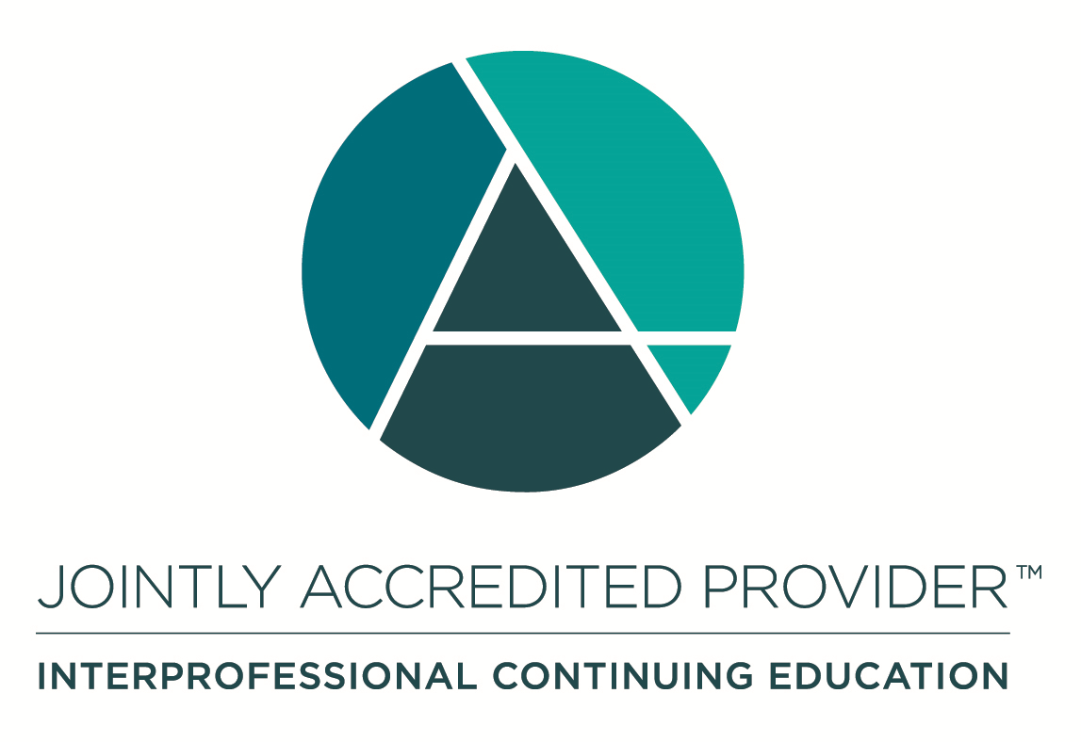
In support of improving patient care, Nationwide Children’s Hospital is jointly accredited by the American Nurses Credentialing Center (ANCC), the Accreditation Council for Pharmacy Education (ACPE), and the Accreditation Council for Continuing Medical Education (ACCME) to provide continuing medical education for the healthcare team. (1.0 CME hours)

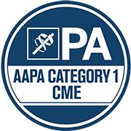

Disclosure of Relevant Financial Relationships and Unapproved Uses of Products

It is policy at Nationwide Children’s Hospital Office of Continuing Medical and Interprofessional Education for individuals who are in a position to control the content of an educational activity to disclose to the learners all relevant financial relationships that they have with any commercial interest that provide products or services that may be relevant to the content of this continuing education activity. For this purpose, we consider relationships of the person involved to include financial relationships of a spouse or partner.

The intent of this policy is to ensure that Nationwide Children’s Hospital CME/CE certified activities promote quality and safety, are effective in improving medical practice, are based on valid content, and are independent of control from commercial interests and free of commercial bias. Peer review of all content was conducted for all faculty presentations whose disclosure information was found to contain relationships that created a conflict of interest relevant to the topic of their presentation. In addition, all faculty were instructed to provide balanced, scientifically rigorous and evidence-based presentations.

IPCE Program DOCUMENT Vers. 1; 4.3.2020

