Activity Name:
- An Update on Pediatric Burns from Nationwide Children’s Burn Program

Date & Time:
- April 20, 2021 - 12:00 PM

Speakers Information:

Sheila Giles
Rajan Thakkar , MD Disclosure(s) - I/we have no financial relationships to report.

Planners Information:

Kathryn Blocher , NP (Activity Coordinator)
Jena Busold, MSN (Activity Coordinator) Disclosure(s) - I/we have no financial relationships to report.

Mary Coles, RN (Activity Coordinator) Disclosure(s) - I/we have no financial relationships to report.

Sheila Giles (Activity Coordinator)
Danna Qunibi, MD (Activity Coordinator) Disclosure(s) - I/we have no financial relationships to report.

Eric Shalosky, EMT (Activity Coordinator) Disclosure(s) - I/we have no financial relationships to report.

Luke Vohsing, MBA (Activity Coordinator) Disclosure(s) - I/we have no financial relationships to report.

Activity Objectives:
1 Explain the recommended process and its steps to obtain a proper TBSA calculation for a pediatric burn patient
2 Calculate TBSA Scores for a range of pediatric burn patients
3 Select the proper medication and its dose for procedural sedation in a pediatric burn patient
4 Compare the fluid management of pediatric burn patients depending on their TBSA
5 Calculate the fluid management of pediatric burn patients based on the Parkland Formula
6 Document amount and times of fluids given to provide quality hand off during transfer

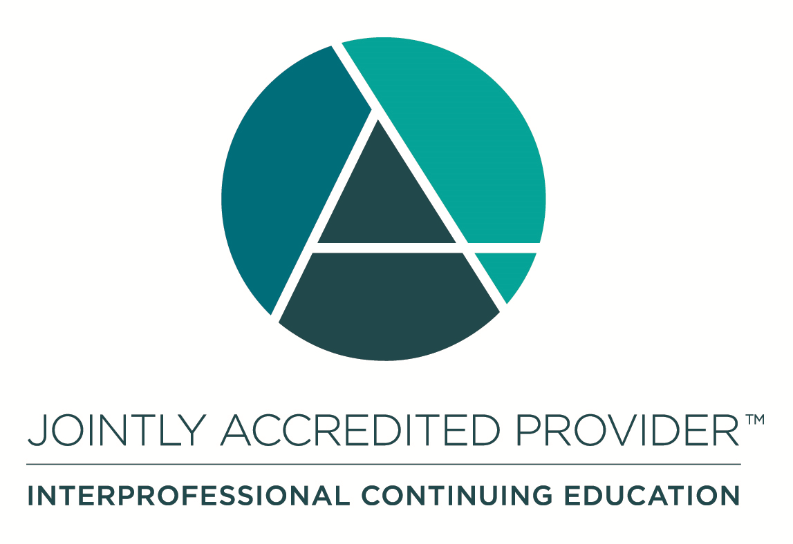
In support of improving patient care, Nationwide Children’s Hospital is jointly accredited by the American Nurses Credentialing Center (ANCC), the Accreditation Council for Pharmacy Education (ACPE), and the Accreditation Council for Continuing Medical Education (ACCME) to provide continuing medical education for the healthcare team. (1.0 ANCC contact hours; 1.0 CME hours)

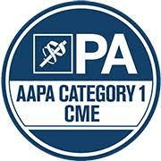

Nationwide Children's Hospital has been authorized by the American Academy of PAs (AAPA) to award AAPA Category 1 CME credit for activities planned in accordance with AAPA CME Criteria. This activity is designated for 1.0 AAPA Category 1 CME credits. Approval is valid for 2 years from the date of the activity. PAs should only claim credit commensurate with the extent of their participation.



Disclosure of Relevant Financial Relationships and Unapproved Uses of Products

It is policy at Nationwide Children’s Hospital Office of Continuing Medical and Interprofessional Education for individuals who are in a position to control the content of an educational activity to disclose to the learners all relevant financial relationships that they have with any commercial interest that provide products or services that may be relevant to the content of this continuing education activity. For this purpose, we consider relationships of the person involved to include financial relationships of a spouse or partner.

The intent of this policy is to ensure that Nationwide Children’s Hospital CME/CE certified activities promote quality and safety, are effective in improving medical practice, are based on valid content, and are independent of control from commercial interests and free of commercial bias. Peer review of all content was conducted for all faculty presentations whose disclosure information was found to contain relationships that created a conflict of interest relevant to the topic of their presentation. In addition, all faculty were instructed to provide balanced, scientifically rigorous and evidence-based presentations.

IPCE Program DOCUMENT Vers. 1; 4.3.2020

