Activity Name:
- Nursing Grand Rounds Enduring

Date & Time:
- August 14, 2025 - 7:00 AM

Presentation Title:
- 2025 Nursing Grand Rounds Enduring: August 14: Executive Leadership Coaching

Speakers & Planners Information:

Name of individual | Individual's role in activity | Nature of Relationship(s) / Name of Ineligible Company(s)
Courtney Bishop, PA-C | Other Planning Committee Member | Nothing to disclose - 04/17/2025
Meghann B Rice, RN | Faculty | Nothing to disclose - 07/23/2025
Melanie S Pinnow, RN | Faculty | Nothing to disclose - 07/23/2025
Deborah Mertz, RN | Faculty | Nothing to disclose - 07/23/2025
Janis Baldwin, RN, MSN, ACM-RN, CSSGB, CMAC | Faculty | Nothing to disclose - 07/23/2025
Susan Copeland, RN, MS, NPD-BC, PED-BC | Activity Coordinator | Nothing to disclose - 11/21/2024
Lauren Fairchild, MSN, RN, NPD-BC | Activity Coordinator | Nothing to disclose - 07/30/2025
Heather E Gribben, MSN | Faculty | Nothing to disclose - 07/28/2025
Lindsey Glaze, PharmD | Other Planning Committee Member | Nothing to disclose - 10/15/2024
Samantha Meadows, DNP | Faculty | Nothing to disclose - 07/23/2025
Ashley Roberts, LISW-S | Faculty | Nothing to disclose - 07/28/2025
Whitney Cushman, MSN | Faculty | Nothing to disclose - 07/23/2025

Session Objectives:

1 Foster Emotional Intelligence and Self-Awareness: Nurses will identify and apply one key executive coaching and strategy to improve interpersonal communication, conflict resolution, and team collaboration within their professional setting.
2 Promote the art of giving feedback: Nurses will be able to demonstrate effective peer feedback techniques by identifying constructive language, applying active listening skills, and providing specific, actionable suggestions that promote growth and collaboration in a supportive learning environment.


In support of improving patient care, Nationwide Children’s hospital is jointly accredited by the American Nurses Credentialing Center (ANCC), the Accreditation Council for Pharmacy Education (ACPE), and the Accreditation Council for Continuing Medical Education (ACCME) to provide continuing medical education for the healthcare team. (1.00 ANCC contact hour(s))

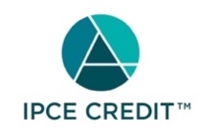

This activity was planned by and for the healthcare team, and learners will receive 1.00 Interprofessional Continuing Education (IPCE) credit(s) for learning and change.

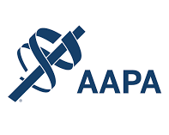

Nationwide Children's Hospital has been authorized by the American Academy of PAs (AAPA) to award AAPA Category 1 CME credit for activities planned in accordance with AAPA CME Criteria. This activity is designated for 1.00 AAPA Category 1 CME credit(s). Approval is valid for 2 years from the date of the activity. PAs should only claim credit commensurate with the extent of their participation.




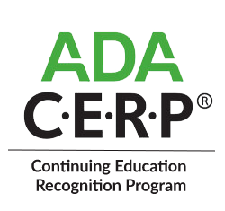

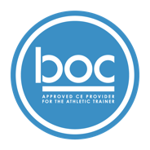


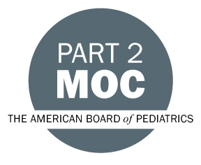

Disclosure of Relevant Financial Relationships and Content Validity

It is policy at Nationwide Children’s Hospital Office of Continuing Medical and Interprofessional Education for individuals who are in a position to control the content of an educational activity to disclose to the learners all relevant financial relationships that they have with any commercial interest that provide products or services that may be relevant to the content of this continuing education activity.

The intent of this policy is to ensure that Nationwide Children’s Hospital CME/CE certified activities promote quality and safety, are effective in improving medical practice, are based on valid content, and are independent of control from ineligible companies (those whose primary business is producing, marketing, selling, re-selling, or distributing healthcare products used by or on patients) and free of commercial bias. Mitigation methods including peer review of all content was conducted for all faculty presentations whose disclosure information was found to contain relationships that created a conflict of interest relevant to the topic of their presentation.

In addition, all faculty were instructed to provide balanced, scientifically rigorous and evidence-based presentations. All recommendations for patient care in accredited continuing education must be based on current science, evidence, and clinical reasoning, while giving a fair and balanced view of diagnostic and therapeutic options. All scientific research referred to, reported, or used in accredited education in support or justification of a patient care recommendation must conform to the generally accepted standards of experimental design, data collection, analysis, and interpretation.

IPCE Program DOCUMENT Vers. 2; 1.6.2022

